Services
Academic Editing and Proofreading

Jacqueline Gamble jacquelinegamble4@gmail.com

The Editor
South African Journal of Higher Education
12 April 2016

This letter serves to verify that ten articles have been submitted to me for editing, by Mrs Lucina Reddy, for submission to South African Journal of Higher Education.

The following editing tasks have been carried out:
Proofreading;
English language editing;
Article structure formatting;
Citation/References cross-check; and
References formatting.

Kind regards
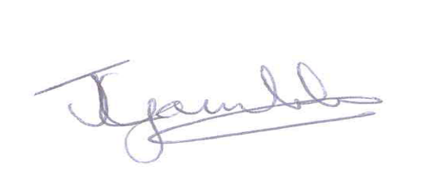

Jacqueline Gamble

