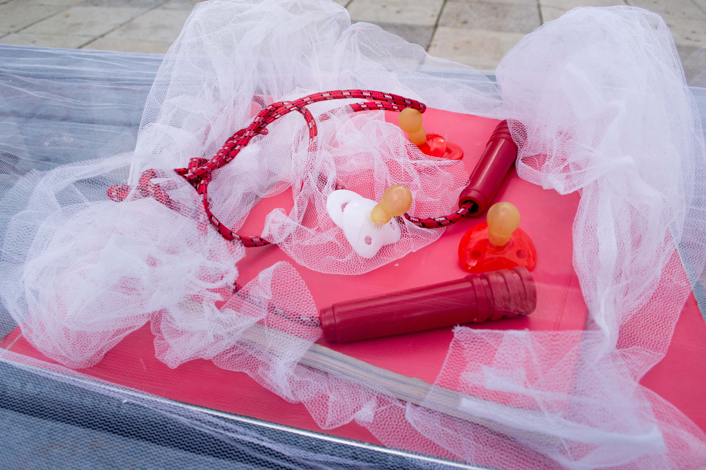
Photograph 1:
Daniel Joubert, Julia Kabat, Bronwyn Katz, Kyu Lee, Melani Louwrens, Nomonde Magadla. Jenna-Lee Maitland, Dumelang Makhooane, Daniel Malan. 2012. The HIV Stigma Project: Misconceptions Organza, Perspex, found objects, clay, paint, Size variable, Temporary installation, Photo by Paris Brummer.

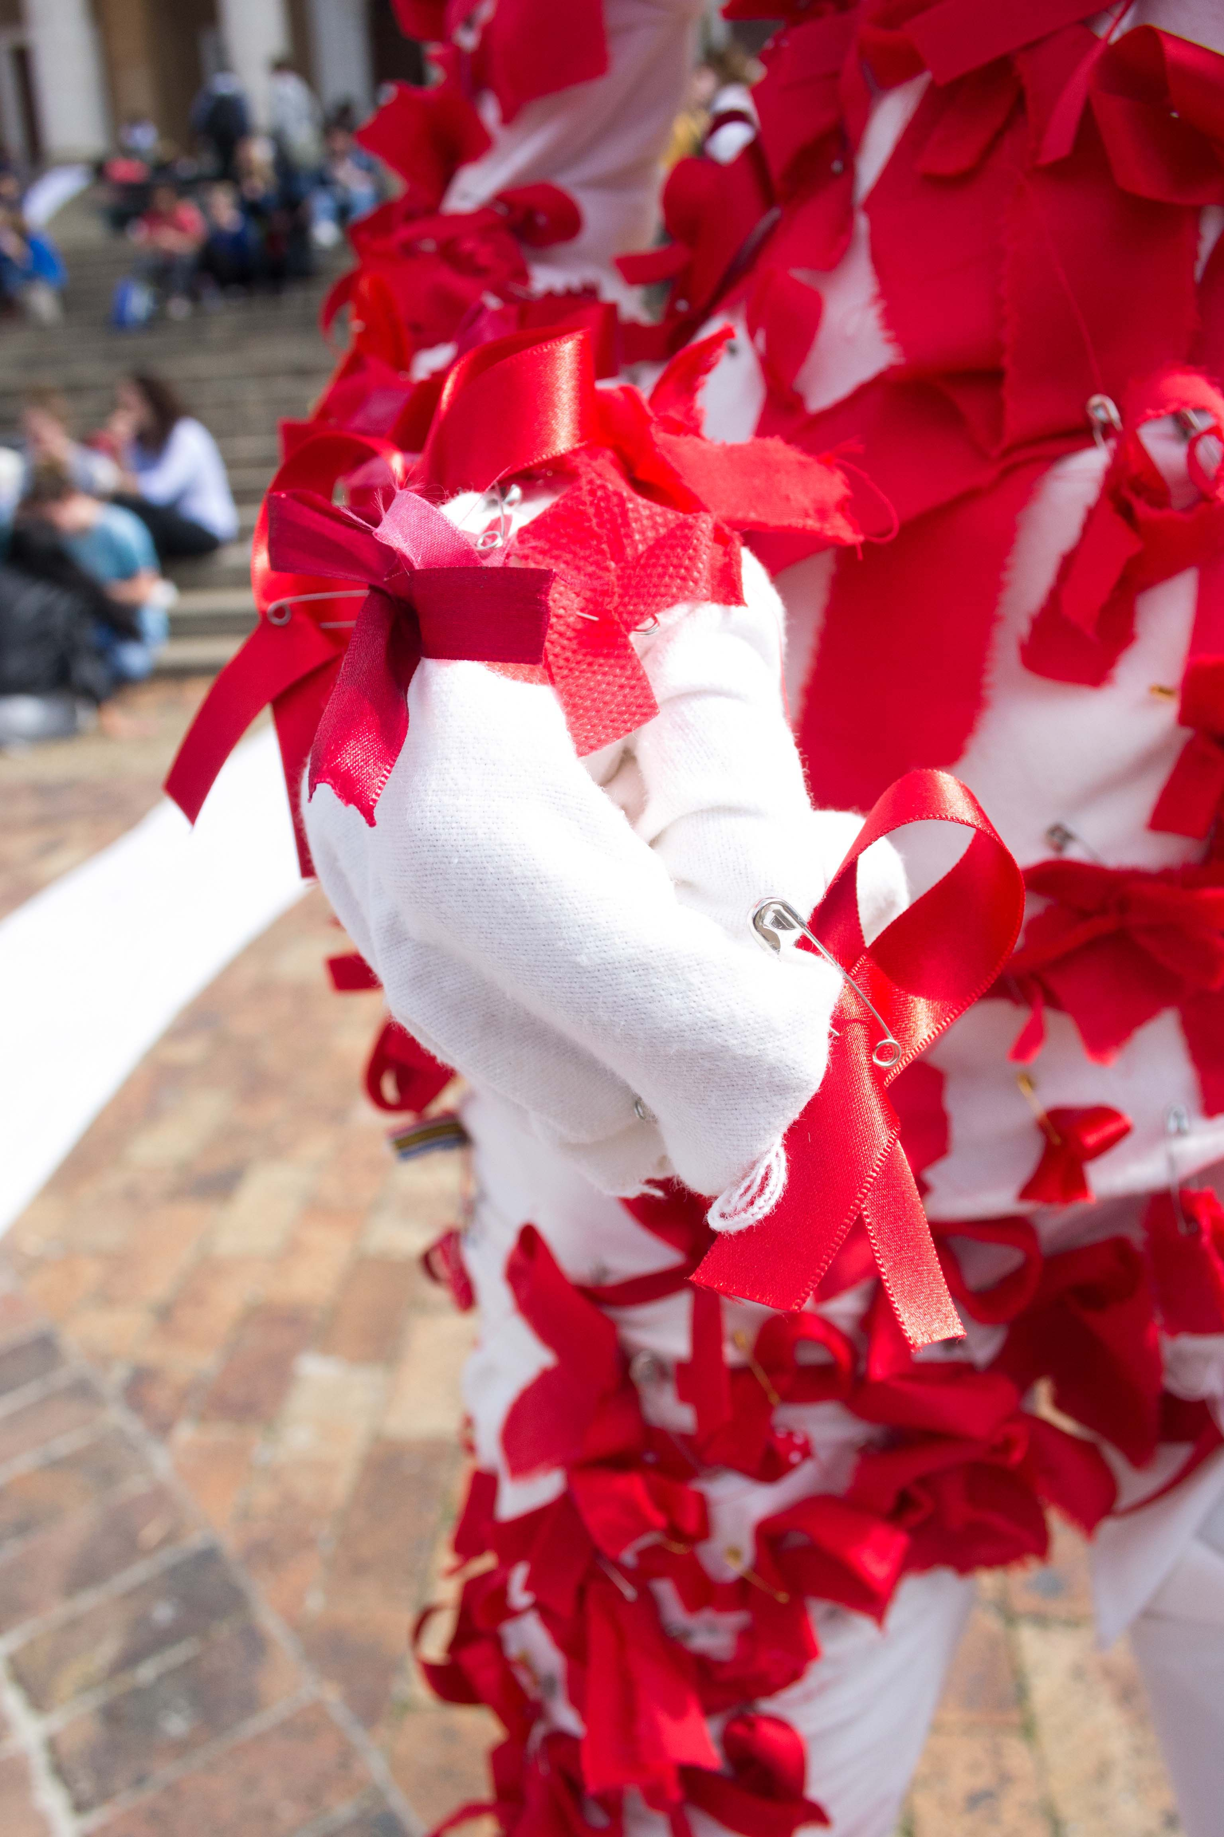

Photograph 2:
Amy Spring, Ruby Swinney, Vanessa Tandwe, Ashleigh Tasker, Lauren Theunissen, Kim Wagner. 2012. The HIV Stigma Project. Mannequin, Mannequin, Red Ribbons, Safety Pins, White fabric. Size variable, Temporary installation, Photo by Paris Brummer.

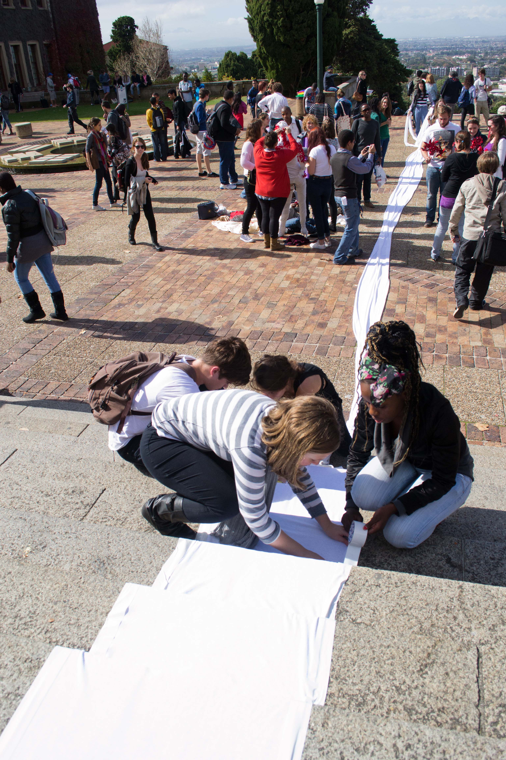

Photograph 3:
Elizabeth Nkoana, Saskia Opperman, Dani Paul, Bert Pauw, Daniela Puccini, Meso Qhobela. Cameron Shefer-Boswell, Danielle Smith, Xanthe Somers, Anna Van Der Ploeg. 2012, The HIV Stigma Project: Footprints, White fabric, Red Paint, Double Sided tape, Duct Tape. Size variable, Temporary installation, Photo by Paris Brummer.

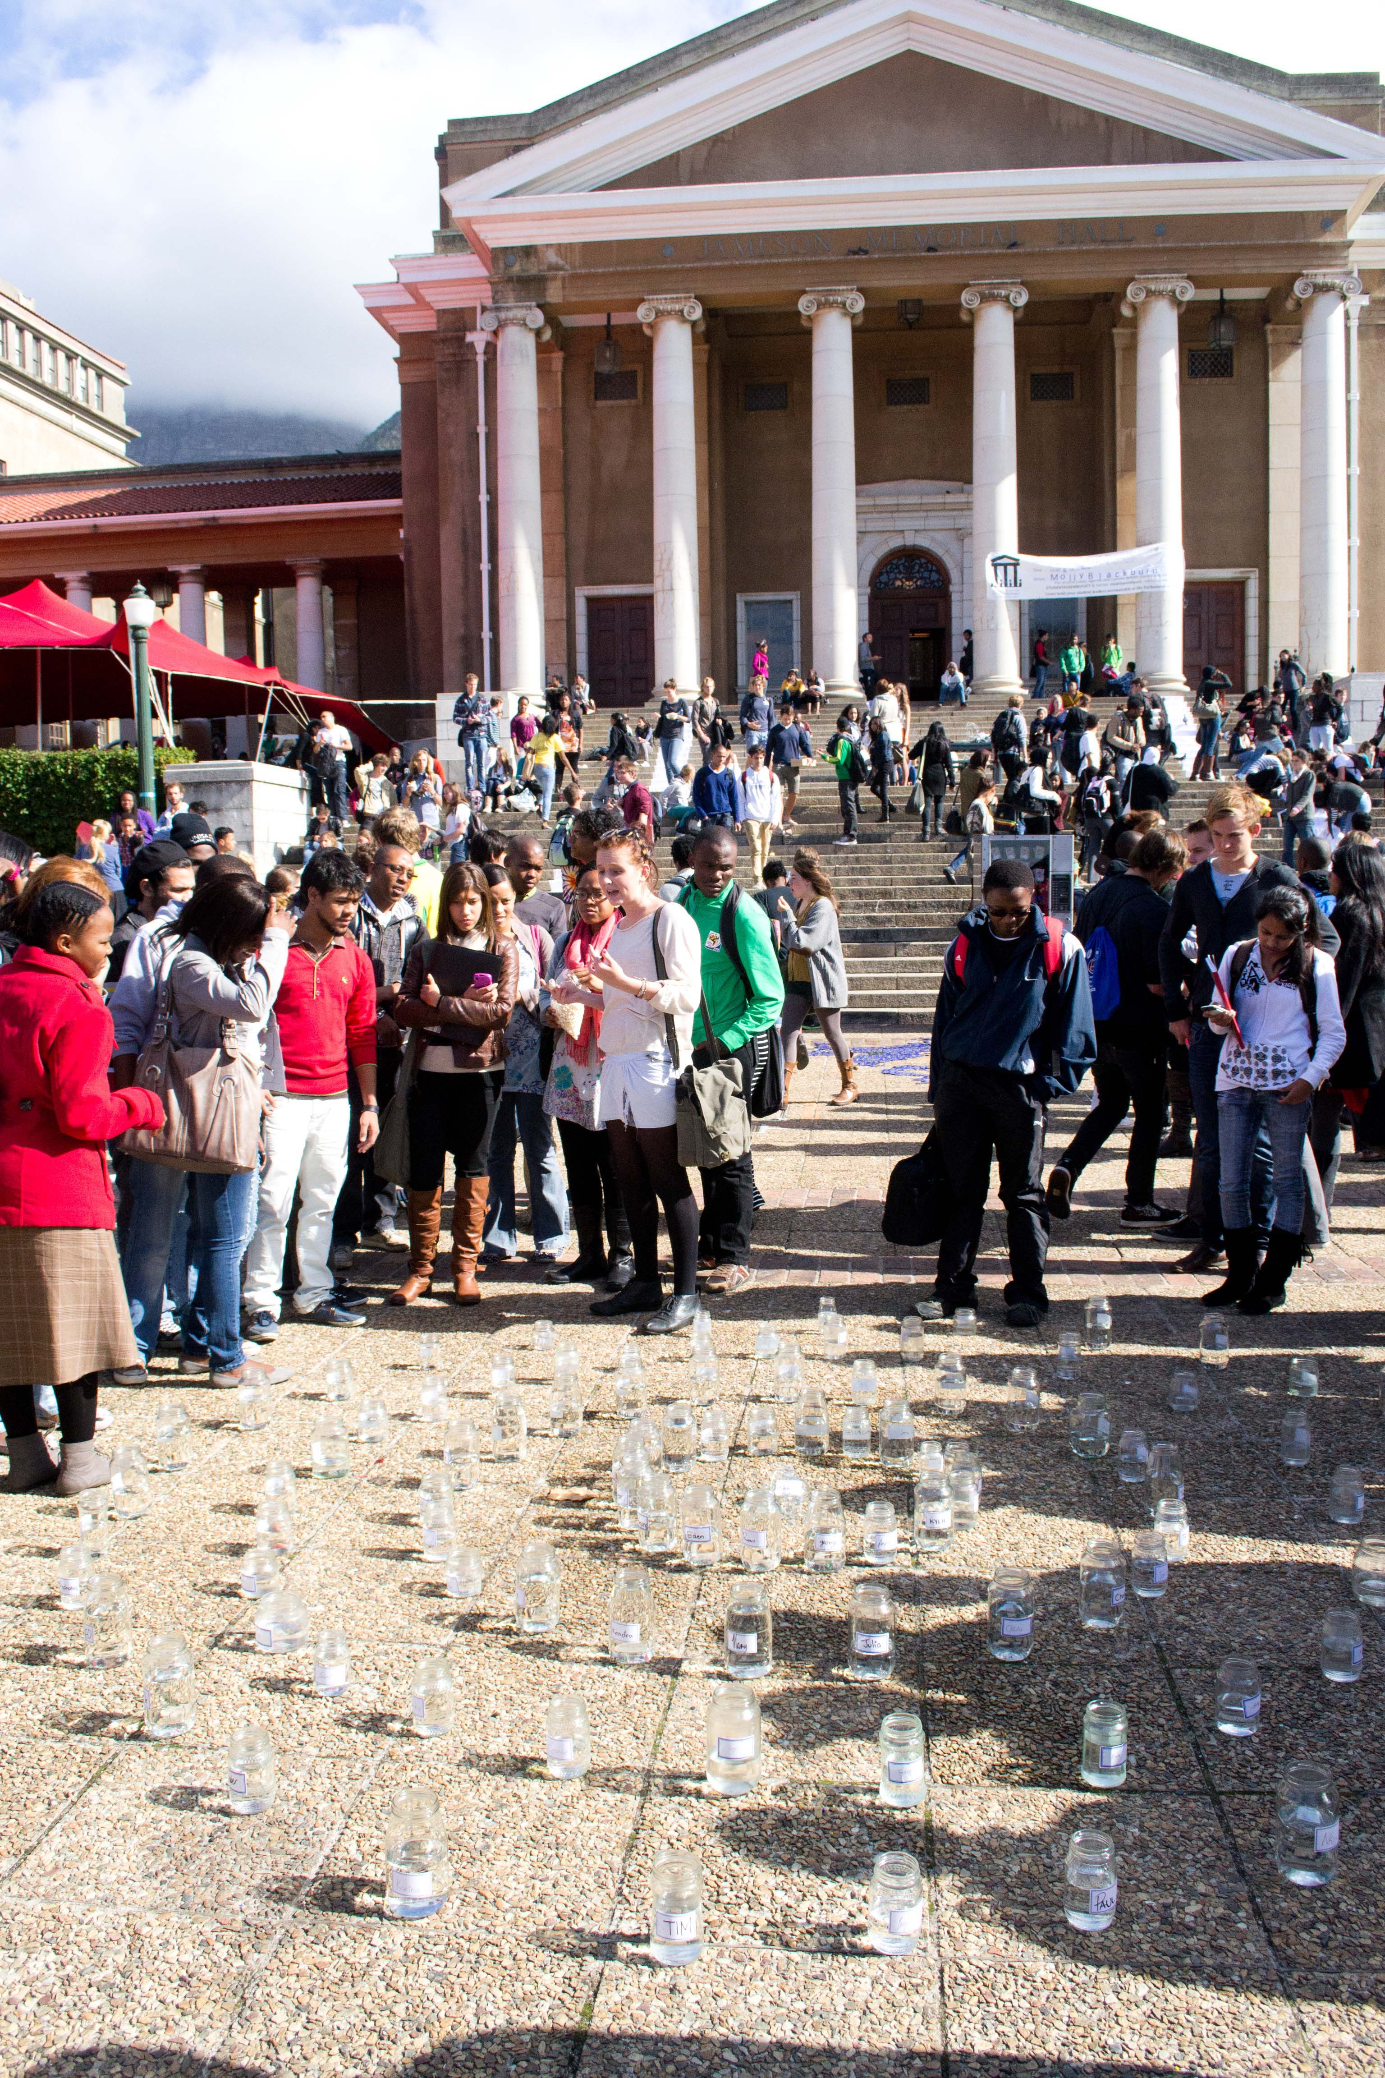

Photograph 4:
Helen Aadnesgaard, Emily Allan, Kirsten Arendse, Michelle Aucamp, Kylie Ballantine. Frances Black, and Paris Brummer. Photographs: Paris Brummer. 2012, The HIV Stigma Project: Fountain, Tap water, Glass jars (various sizes), Self-adhesive Labels, Ink, Size variable, Temporary installation, Photo by Paris Brummer.

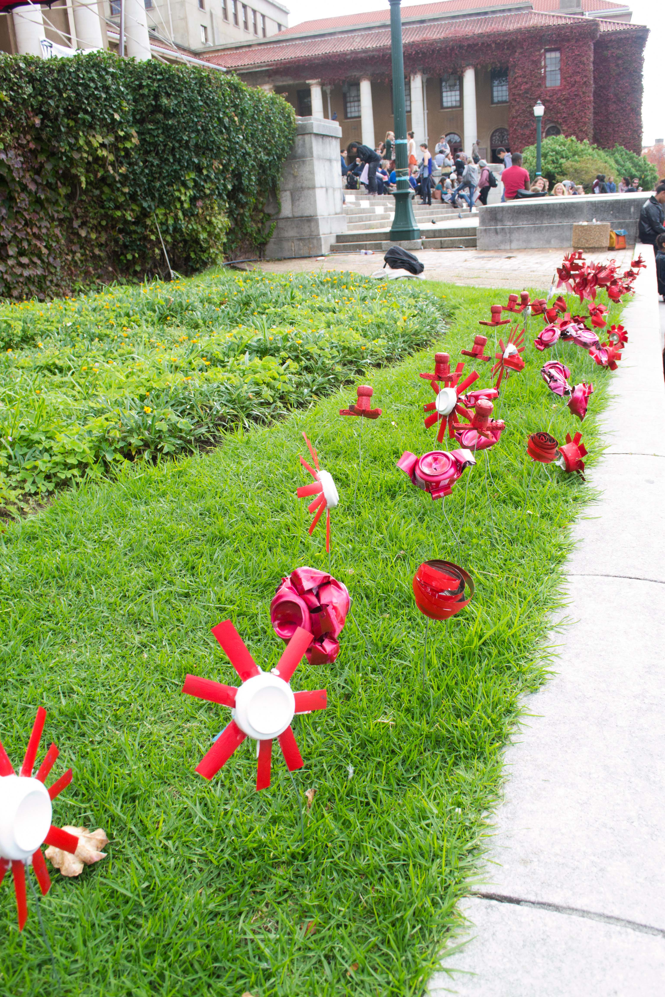

Photograph 5:
Ruan Maree, Jane Matthews, Pola Mazus, Jess Metcalfe, Siwa Mgoboza, Caitlin Mkhasibe, Gitte Moller, Pamela Mulock-Bentley. 2012, The HIV Stigma Project: Flowers, Altered tin cans, Wire, Glue, Red paint, Size variable, Temporary installation, Photo by Paris Brummer.

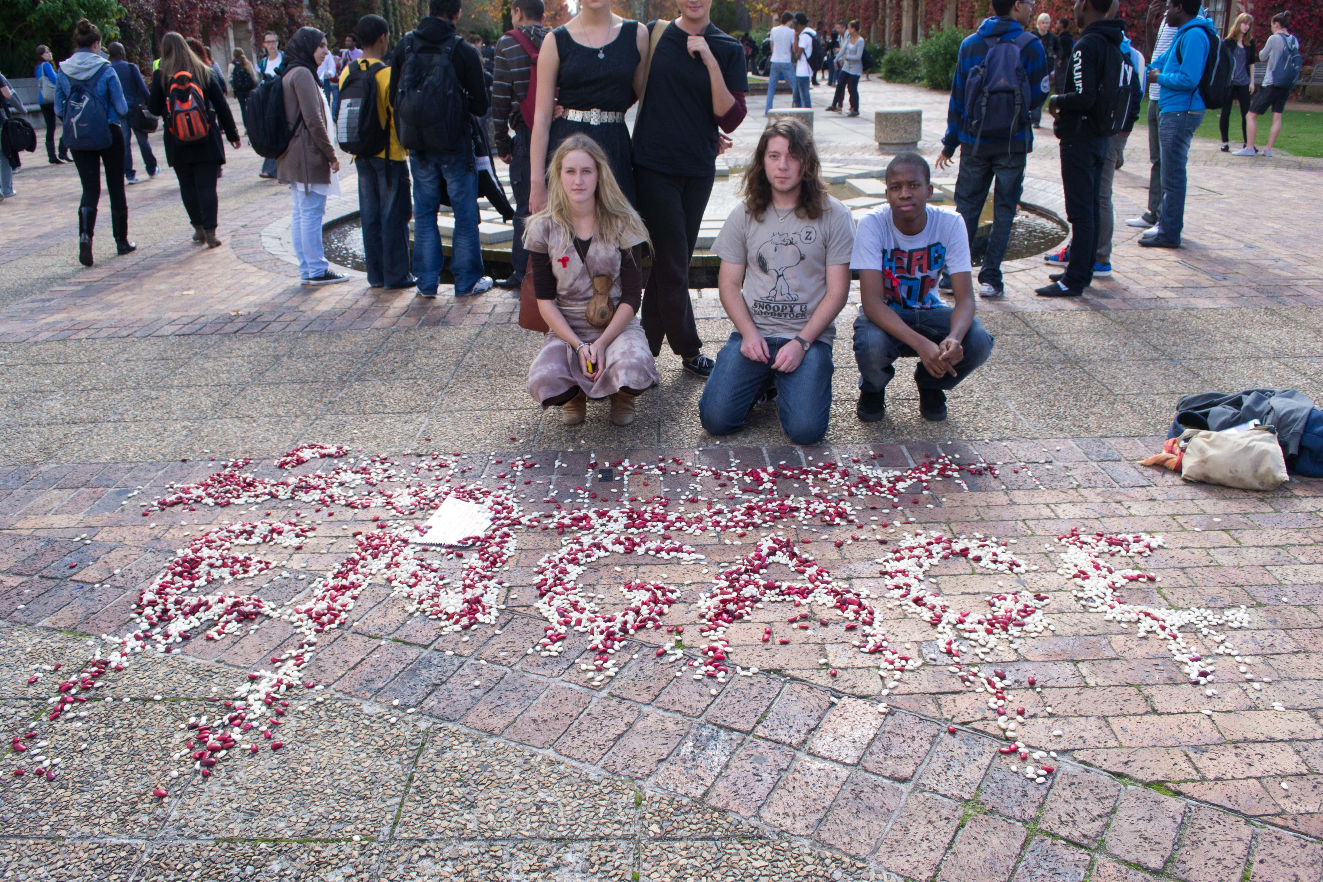
Photograph 6:
Martin Wilson, Michaela Younge, Kylie Wentzel, Clara Wyma, Eileen van Aswegen, Katlego Tlabela. 2012. The HIV Stigma Project: Beans. Red and White Beans. Size variable, Temporary installation, Photograph by Paris Brummer.

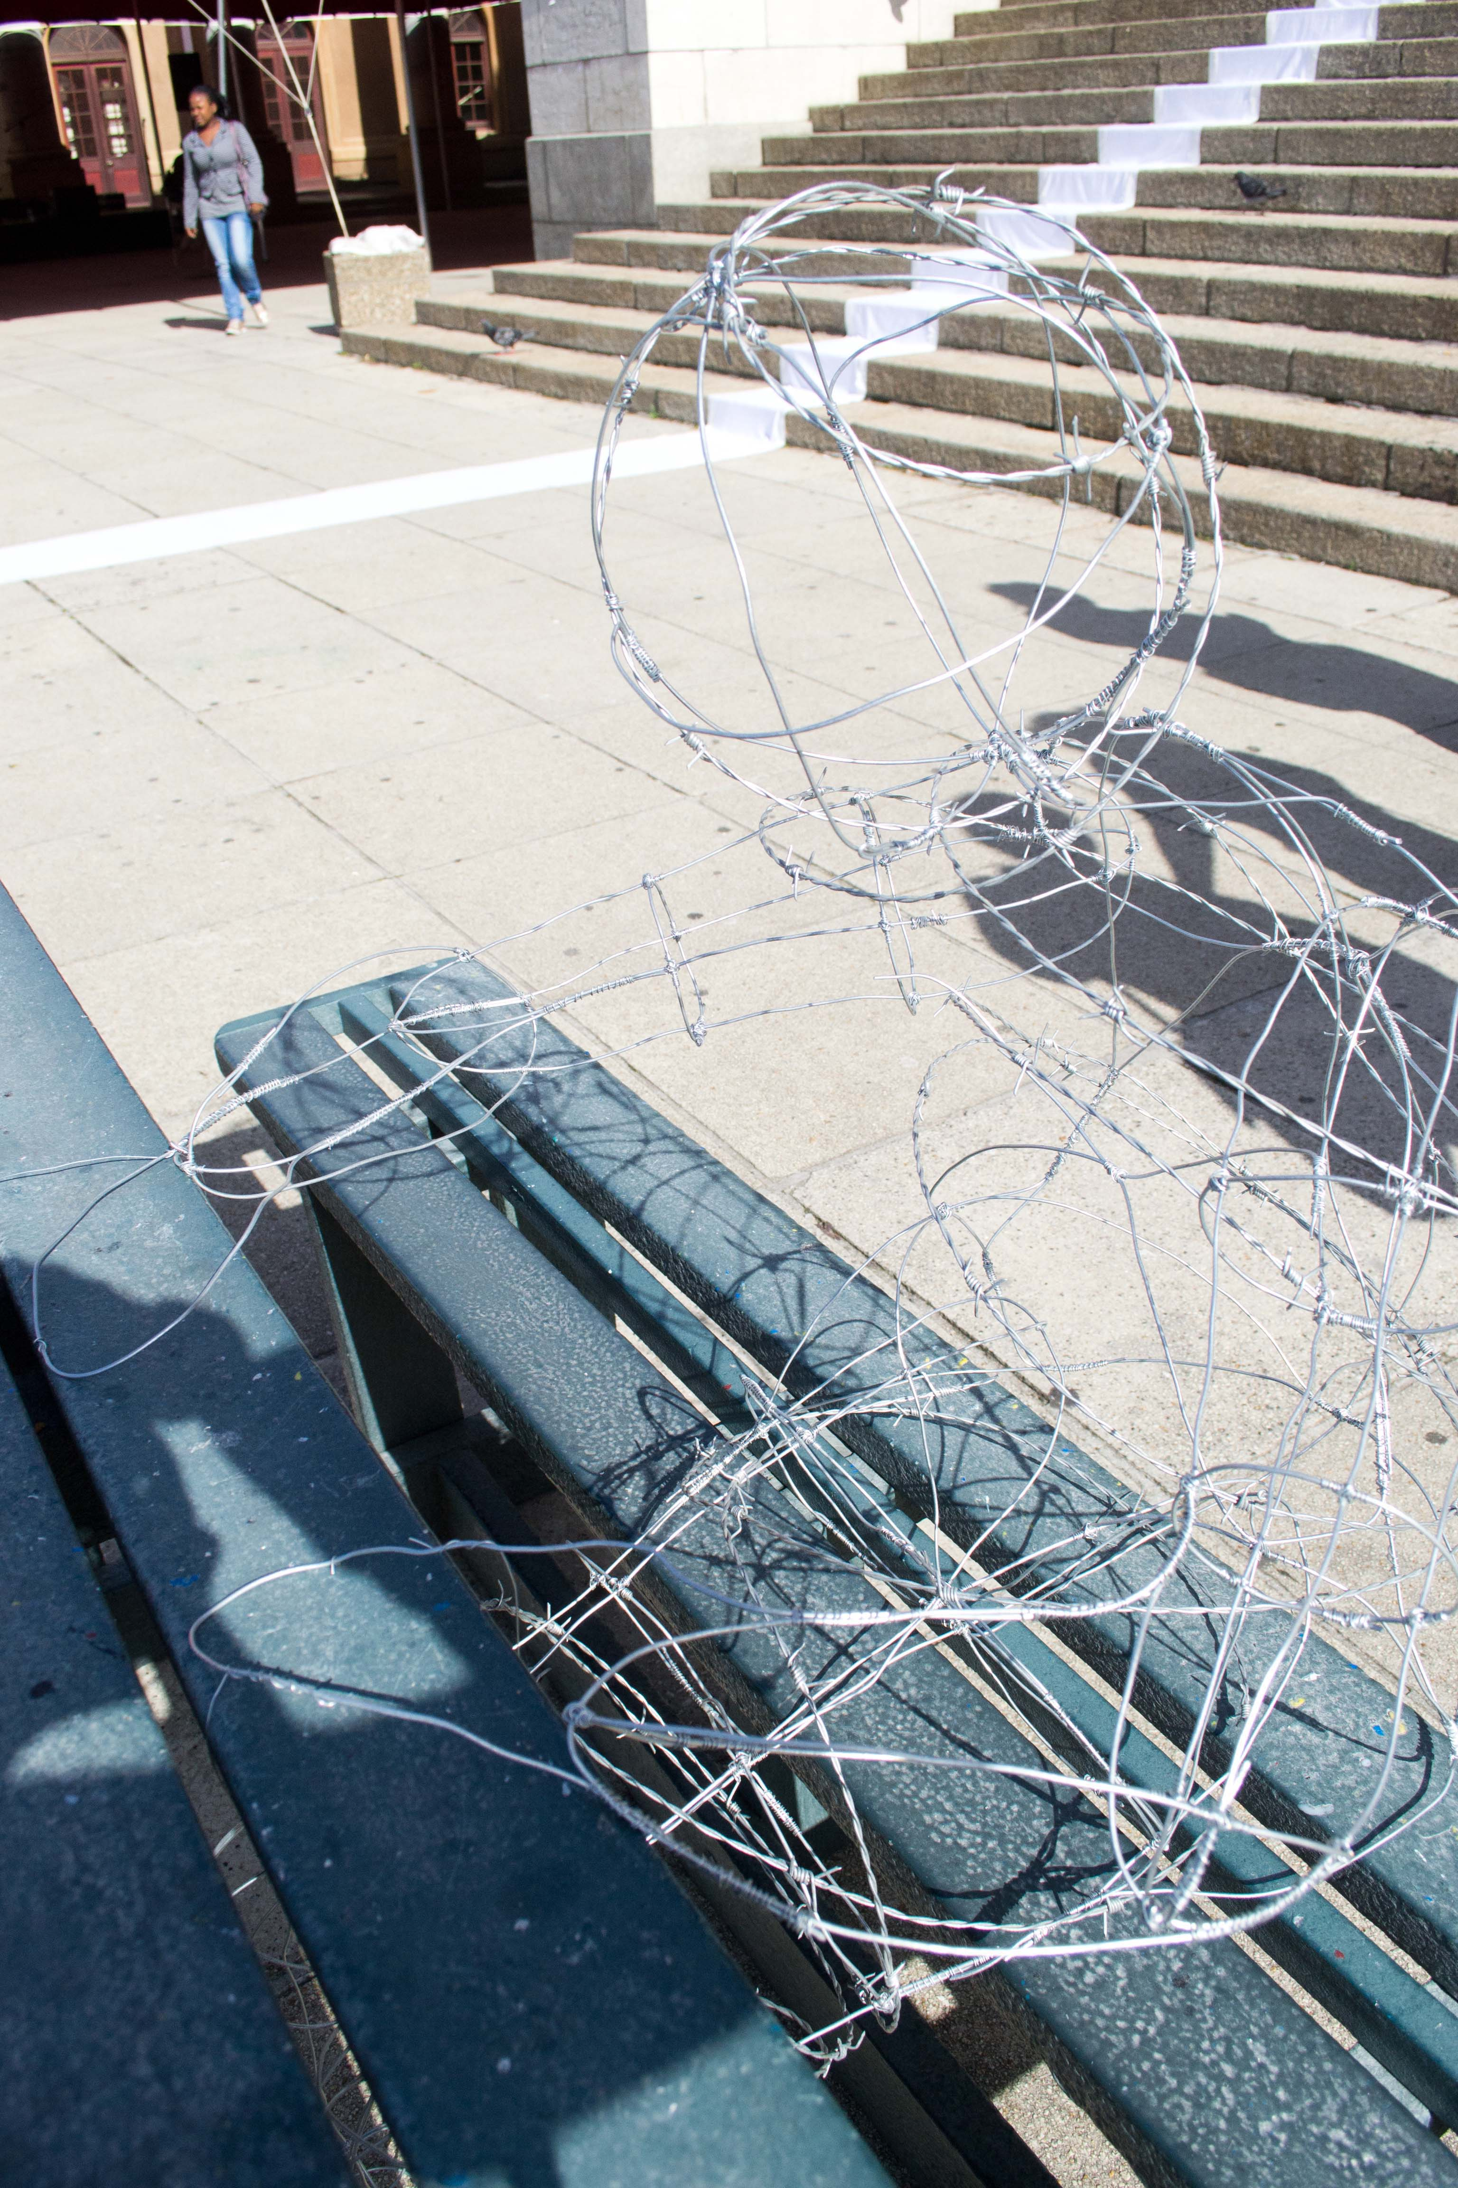

Photograph 7:
Michael Goldsmid, Susan Greeff, Rupert Green, Sandy Harris, Caitlin Hocking. Mikayla Humphries, Lindi Jansen Van Rensburg. 2012. The HIV Stigma Project: Barbed-wire Figure. Barbed-wire, wire, Temporary installation, Photograph by Paris Brummer.
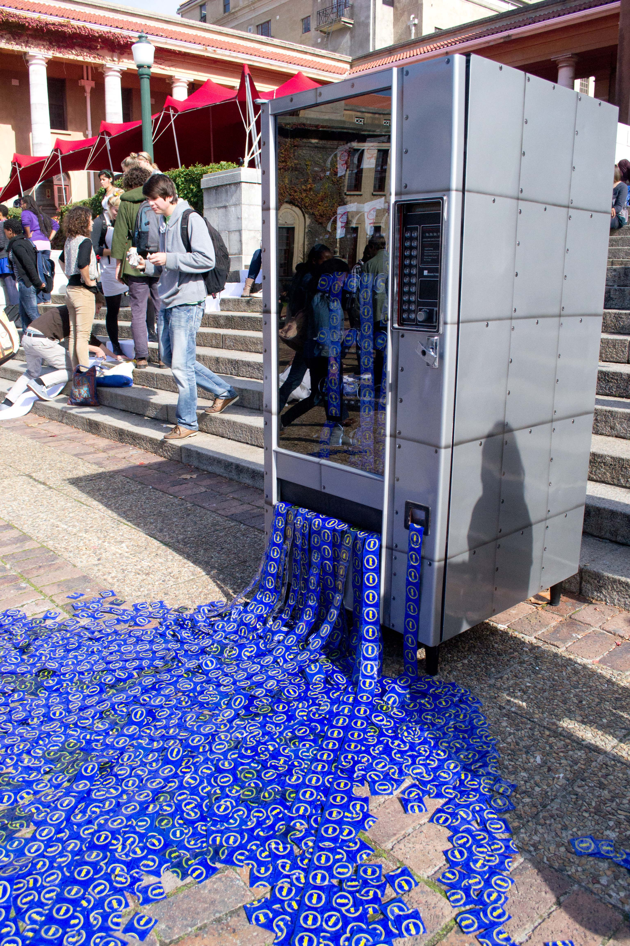
Photograph 8:
Chiedza Chimwaza, Laura Chittenden, Jolandi Coetzee, Kasey Davies, Elize De Beer, Tamsyn Dodds, Cleo Du Plessis, Kate Eriksen, 2012. The HIV Stigma Project: Vending Machine. Choice Condoms. Vending machine. Size variable, Temporary installation, Photograph by Paris Brummer.

