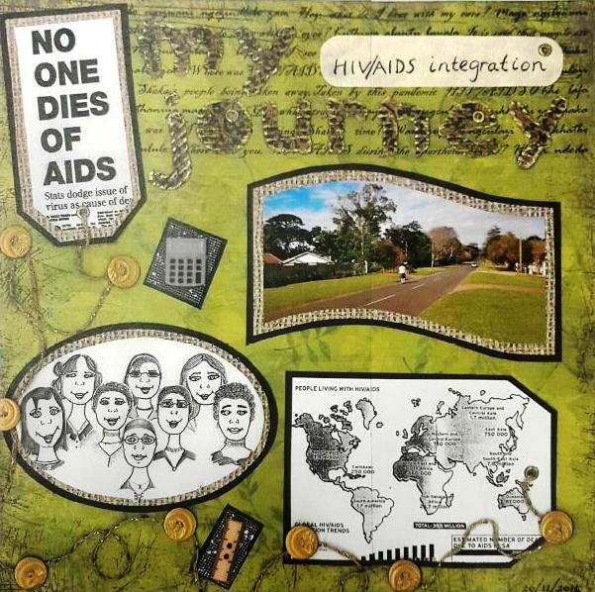

Figure 1: Van Laren’s scrapbook page: ‘My HIV and AIDS integration journey’

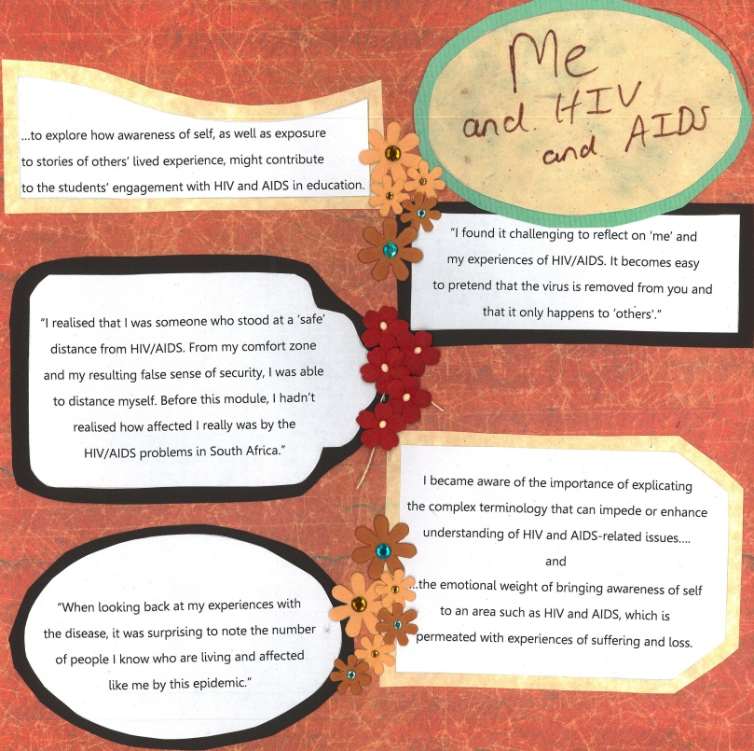
Figure 2: Pithouse-Morgan’s scrapbook page: ‘Me and HIV and AIDS’

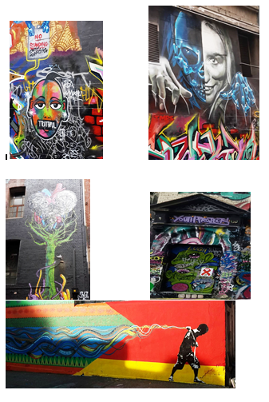
Figure 3: Volks’ scrapbook page, ‘Youth art/health Xchange’

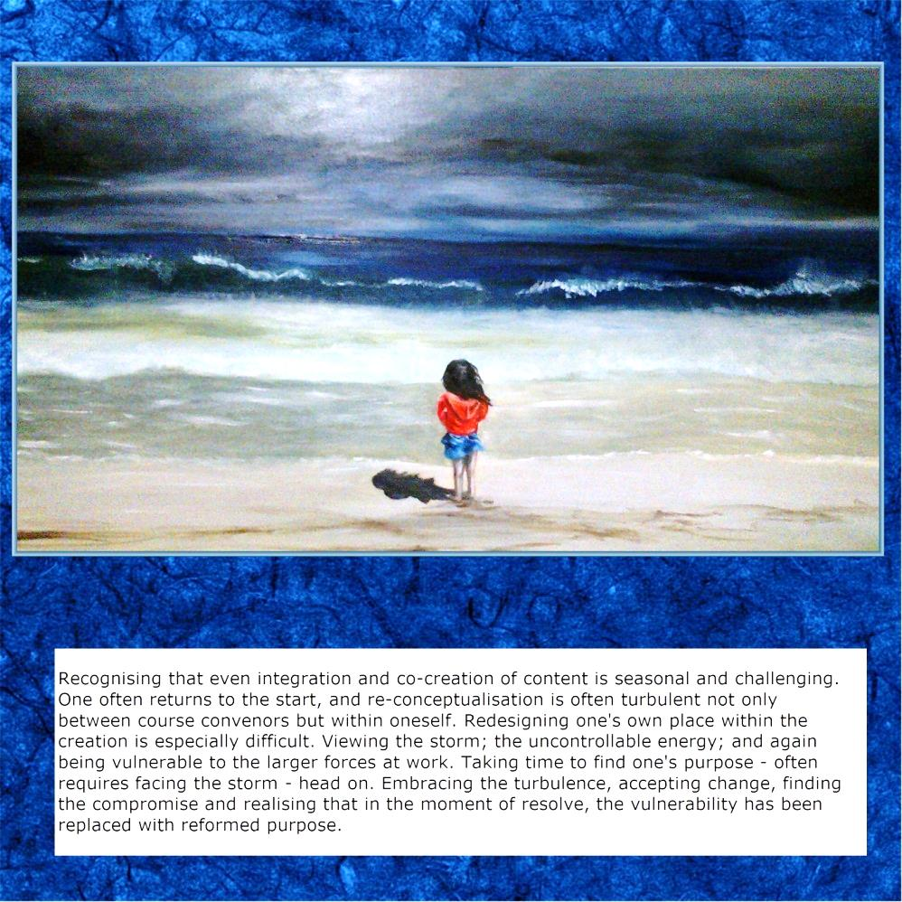
Figure 4: Abrahams’ scrapbook page, ‘Transform’
Figure 5: Van Laren’s scrapbook page: ‘My HIV and AIDS integration journey’

Figure 6: Pithouse-Morgan’s scrapbook page: ‘Me and HIV and AIDS’

Figure 7: Volks’ scrapbook page, ‘Youth art/health Xchange’

Figure 8: Abrahams’ scrapbook page, ‘Transform’

awareness of self, self-awareness sees herself as an HIV and AIDS integrator she sees herself as the person battling to move students she sees herself as having a “large” caring heart to connect self-awareness, stories and lived experiences unable to distance herself from the epidemic view one’s self at a distance bravely (re)commits herself placed herself slightly off centre no thread pulling together the label and the image of the “self”. Placed slightly below the “self” I found myself rethinking the fact that it reflects herself in this way comes from a place of deep self-reflection. Placing herself in this way the emotional weight of bringing awareness of and asking oneself (as a lecturer, student and learner) to go to places to explore how awareness of self might contribute to students’ engagement, considering oneself and placing oneself in feminist frameworks of self-empowerment and independence. Turbulence not only between others but also within oneself

Figure 9: An extract from the composite text of our professional learning reflections

Found poem
Portrait of an HIV and AIDS integrator

Unable to distance her self
The emotional weight
Turbulent within her self
Placed her self
Off centre

Self-empowerment
Comes from
Deep self-reflection
Re-thinking her self

Asking her self
To go to places
To connect, engage

Figure 10: A found poem: Portrait of an HIV and AIDS integrator

