Figure 1: Examples of theme 1
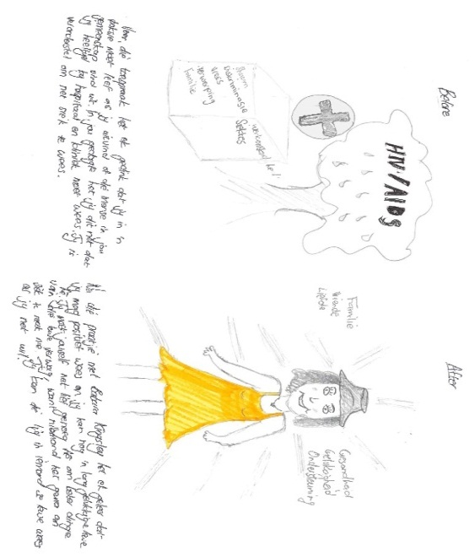  Picture 1 | 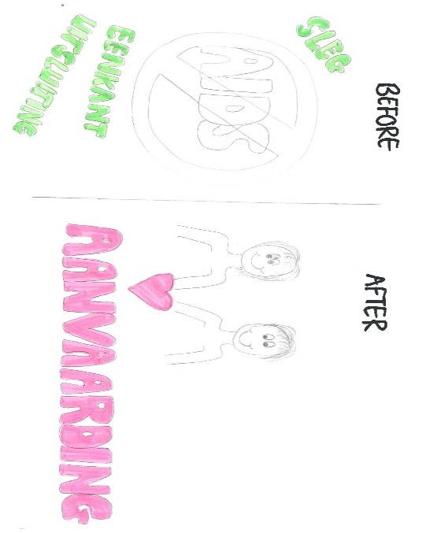  Picture 2
Before  Discrimination, fear, rejection from family.  I thought if you are HIV positive that you all the time have to visit hospitals and clinics  I thought you constantly feel ill. | Before  Bad  Isolation  Rejection
After  Love, happiness, support, family, friends.  HIV positive people can live a long life. Love yourself and expect better things in life. You can be the light in someone’s life if you are willing. | After  Acceptance
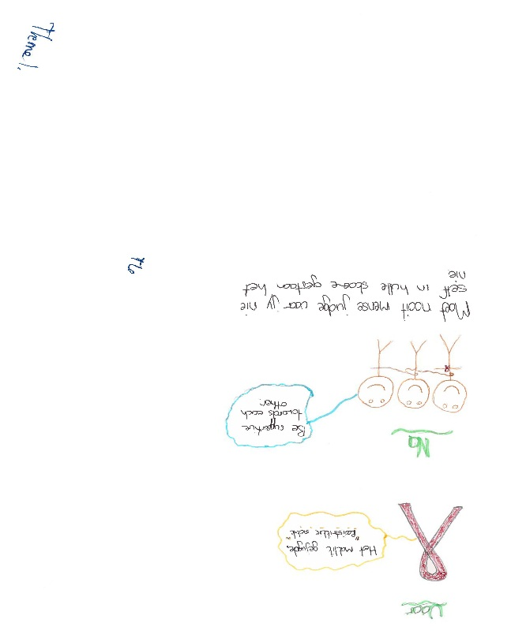  Picture 3 | Picture 3: Before  The easy youthful ‘redribbon’ disease.  After  Be supportive towards each other.  Don’t judge people if you have not walked in their shoes

Figure 2: Examples of Theme 2
Picture 1 1  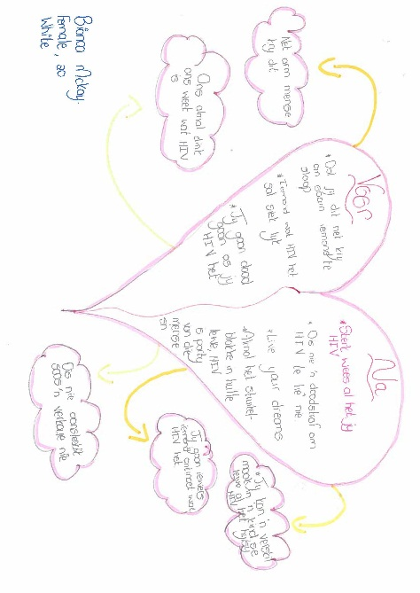 | Picture 2  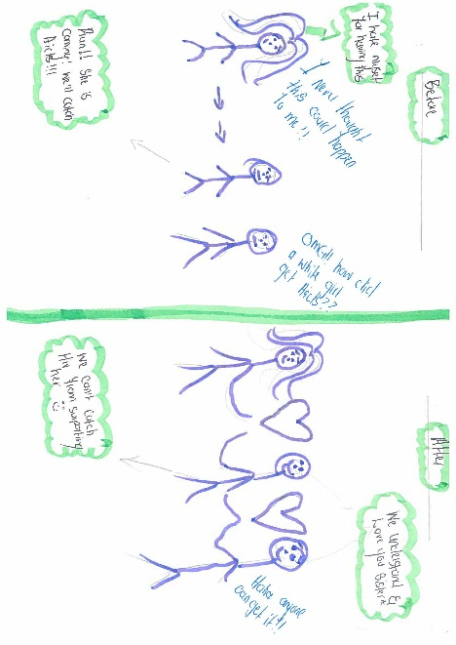
Before  Only poor people get infected  A person living with AIDS is visibly identifiable  You only get infected by sleeping with many partners  You die if are HIV positive | Before  OMG how did a White girl get AIDS  I hate myself for having this  I never thought this could happen to me  Run she is coming, we will get AIDS
After  You make a difference in a life of a child  It is not a death sentence  It is not as infectious like flu symptoms  Live your dreams | After  We understand, love you sister  Anyone can get it  We can’t get HIV from supporting her
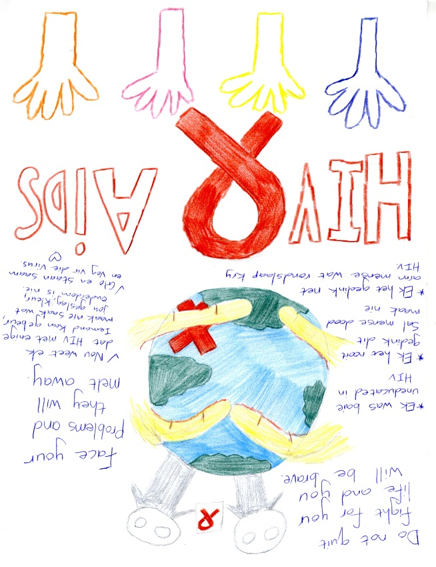  Picture 3 | Picture 3 Before  I thought it was only poor people with multiple sex partners that get infected  After  I now know that anyone can get infected regardless your gender, race or age.  Belief and unite to fight this virus.  Face your problems they will melt away  Do not quit the fight for your life and you will be brave.

Figure 3: Examples of Theme 3
Picture 1  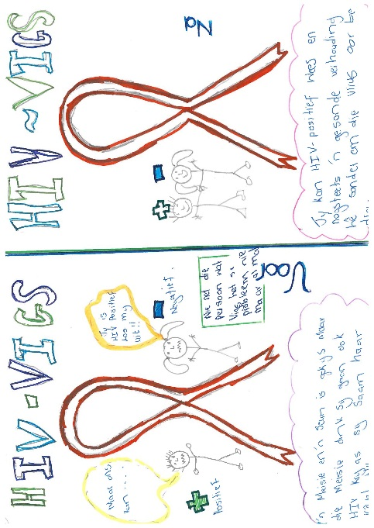 | 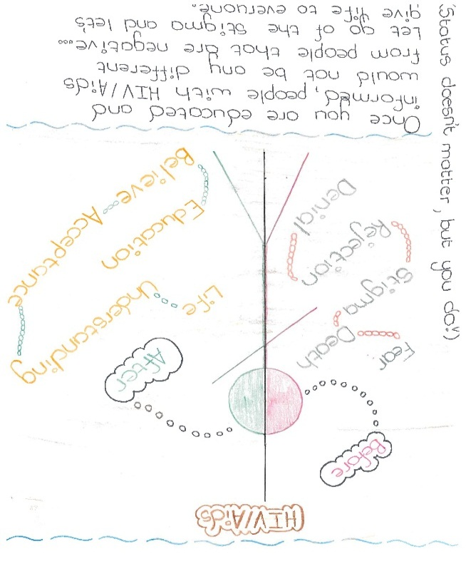  Picture 2
Before  You are HIV positive leave me alone  This become everyone’s problem  The girls will get HIV just by being with their boyfriends | Before After  Fear Understanding  Death Life  Rejection Acceptance  Denial Belief  Status does not matter, you do!
After  You can be HIV positive and still have a healthy romantic relationship without transmitting the disease. | After  Once you are educated and informed, people with HIV/AIDS would not be any different from people that are negative. Let go of the stigma and give life to everyone
Picture 3  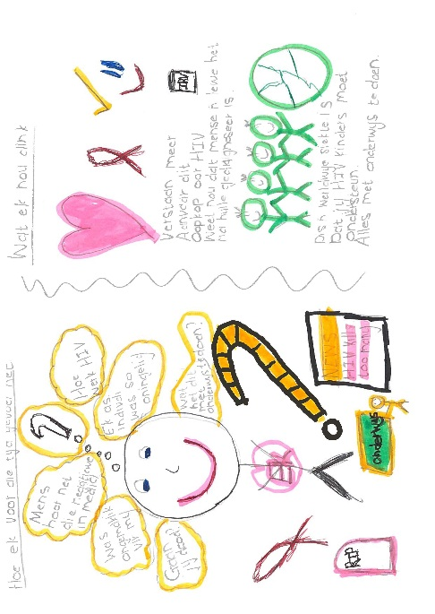 | Picture 3: Before  What does this have to do with education?  It (the lecture) was uncomfortable for me.  How does HIV work?  People only hear about the negative in the media.  After  You should be open-minded about it  People have a life even though they are diagnosed with HIV  Teachers should support children infected and affected with HIV  I understand it better now

Figure 4: Examples of Theme 4
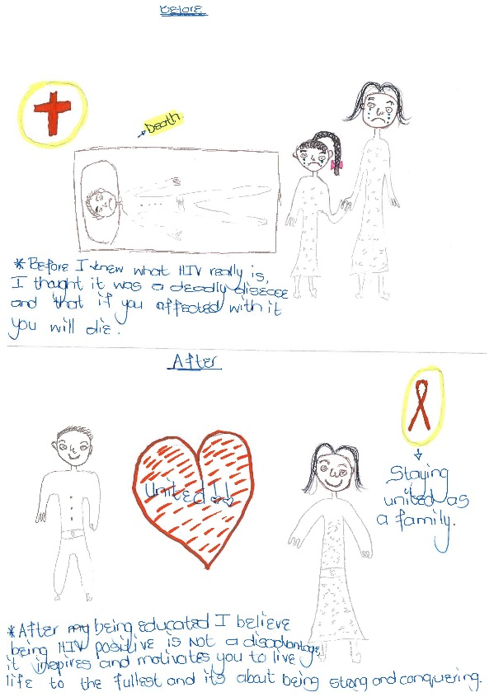  Picture 1 | Picture 2  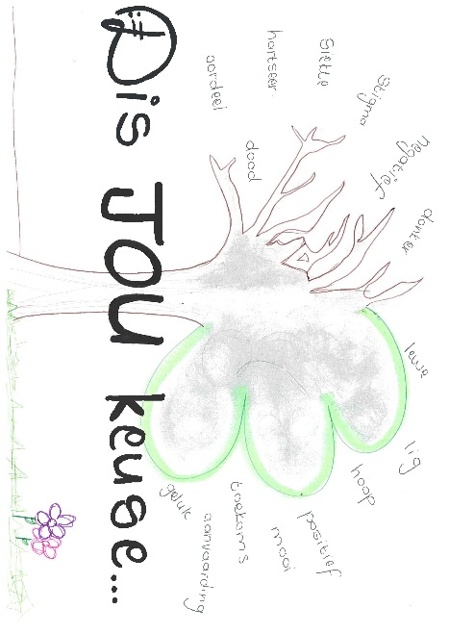
Before  I thought it was a deadly disease and if you get infected, you die. | Before  Darkness; negative; stigma; illness; sadness; death and judgment.
After  Being HIV positive is not a disadvantage, it inspires and motivates you to live life to the fullest and about being strong and conquering. | After  Life; light, hope; positivity; future; happiness; future.
Picture 3  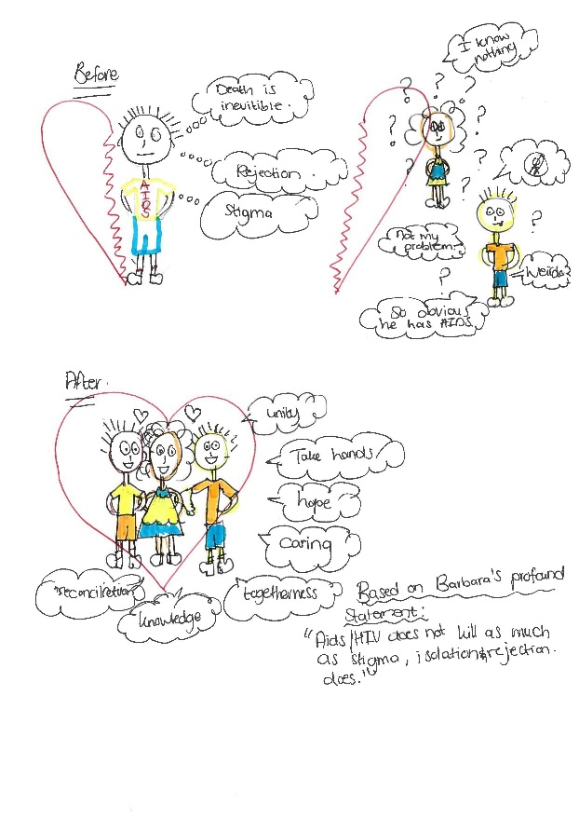 | Picture 3: Before  Death is inevitable.  Rejection.  Stigma.  Not my problem.  I know nothing.  So obvious he has AIDS.  After  Unite  Take hands  Hope  Caring  Togetherness  HIV/AIDS does not kill as much as stigma, isolation and rejection do.

