Tables and Figures

Tools

Object

Rules

Community

Outcome

Division of labour

Subject

Figure 1: Cultural-historical Activity Theory Model of Human Activity (Engeström, 1987)

Tools:

time, money,

curriculum, media,

language discourse,

colleagues, resources,

principal, textbooks

Object:

effective LO curriculum implementation,

learner & teacher knowledge, improved quality of life

Rules:

acts, policy, curricular, principal and authorities,

required qualifications, regulations, norms, values

Community:

school, learners, teachers, SGB, administrators, CBO, Parents, DoE, NGO, FBO, other governmental stakeholders

Outcome:

constitutional transformational values,

meet LO teachers’ needs,

career development and advancement

Division of labour:

joint activity,

roles and status,

power issues, new career development responsibilities,

responsibilities defined by the rules and the community

Subject:

LO teacher

Figure 2: LO teachers’ career development needs from an activity system: Adapted from Engeström (1987)

Intrinsic needs

Extrinsic needs

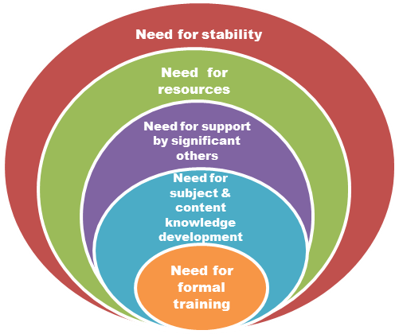

Figure 3: LO teachers' career development needs: From an intrinsic level to an extrinsic level

Tools:

time, money, curriculum, LTSM, language discourse

Object:

effective LO curriculum implementation, learner and teacher knowledge

Rules:

acts, policy, curricular, principal and authorities,

required qualifications, regulations, norms, values

Community:

school, learners, teachers, SGB, administrators, CBO, Parents, DoE, NGO, FBO, other governmental stakeholders

Outcome:

educational, constitutional, transformational, civic, and social responsibility

Division of Labour:

joint activities at school, timetable allocation, roles and status, power issues, new career development responsibilities,

responsibilities defined by the rules and the community

Subject:

LO teacher’s internal tension:

values, beliefs, generation gap, personal experiences, becoming competent

Subject:

LO teacher

**Figure 4:** T**ensions amongst various activity systems of LO teachers’ career development**

needs (represented by arrows)

Table 1: Profile of participants

|  |  |  |  |  |  |  |  |  |
| --- | --- | --- | --- | --- | --- | --- | --- | --- |
| Phenomenological individual interviews with LO teachers | | | | | | | | |
| Pseudonyms | Gender | Race | | | Position held | Teaching experience | Years of teaching LO | Highest Qualification |
| Lilly | F | White | | | HOD | 26 | 26 | M Ed Psych |
| Puleng | F | Black | | | HOD | 18 | 18 | B Ed |
| Liziwe | F | White | | | HOD | 23 | 23 | 4-year diploma |
| Rebone | F | Black | | | HOD | 17 | 17 | B Ed Honours |
| Martha | F | White | | | Principal | 24 | 24 | M Ed |
| Kate | F | Indian | | | LO coordinator | Not provided | 3 | D Ed |
| Sebonelo | F | Black | | | LO coordinator | Not provided | 4 | M Ed |
| Group member (Codes used) | | | | | | | | |
| FG1P1 | M | | Black | Principal | | 23 | 2 | B Ed |
| FG1P2 | F | | Black | HOD | | 31 | 2 | B Ed |
| FG1P3 | F | | Black | Teacher | | 15 | 4 | B Ed |
| FG2P1 | F | | White | Teacher | | 3 | 3 | Master’s |
| FG2P2 | F | | Black | Teacher | | 13 | 13 | Honours |
| FG2P3 | F | | Coloured | Teacher | | 1 | 1 | Honours |
| FG2P4 | M | | Black | Teacher | | 10 | 2 | Honours |
| FG2P5 | F | | Black | Teacher | | 12 | 5 | Honours |
| FG2P6 | F | | Black | Teacher | | 18 | 5 | Honours |