Marisa Honey
PO Box 7504, Stellenbosch, 7600
Tel. 021-889 6688 Cell. 082 412 8642
e-mail: marisahoney@iafrica.com

2 March 2016

To Whom It May Concern:

Hereby I, Marisa Freya Honey, declare that I am a full-time editor and translator with 16 years’ experience of, among other things, editing theses, dissertations and journal articles. I also wish to state that I undertook a linguistic edit of the article, Social career influences of Xhosa adolescents elicited using the Systems Theory Framework in a peri-urban South African township, on behalf of Ms Anouk J. Albien.

My qualifications are the following (all degrees obtained at Stellenbosch University:

BA (1984)
BJournalism (Hons) cum laude (1986)
BA (Hons) Philosophy (1988)
MPhil (Translation) cum laude (2006)

The latter degree had a large bilingual (Afrikaans and English) editing component.

Please feel free to contact me should you have any queries.

Kind regards
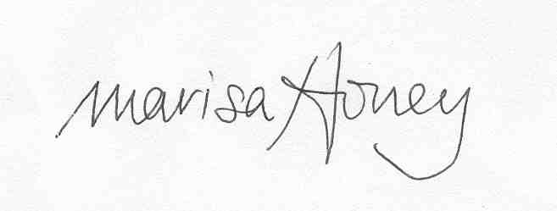

Marisa Honey

