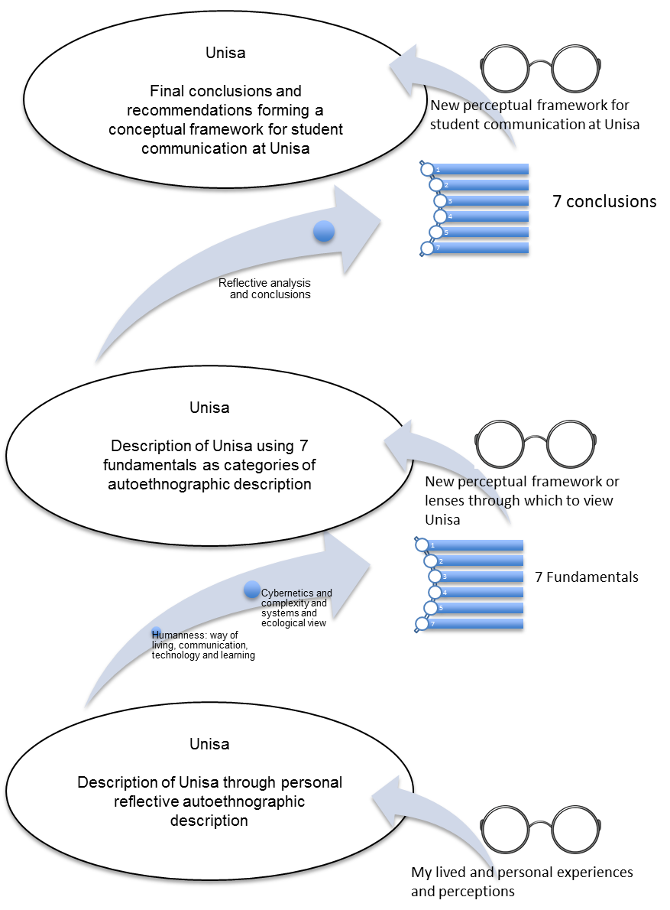

Figure ‎1: Recursive process of philosophical reflection through analytical autoethnography

