Statement by language editor
I hereby declare that I language edited an article with the title:

“Taking stock of South African accounting students’ pervasive skills development: Are we making progress?”

Jennifer Lake
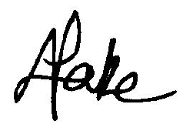
Accredited Professional Text Editor, SATI (APEd)
Membership no: 1002099
M.St. (Oxon)

