|  |  |  |
| --- | --- | --- |
| bd19816_ **Dr Edith H. Katzenellenbogen** Research Advising & Manuscript Editing 243 Helderberg Village, Private Bag X19  Somerset West 7129, South Africa  Tel/Fax: +27 (0)21 855-3061 Mobile: 072 12 777 52 Email: ekatzie7@gmail.com |  | bd19816_ **Dr Edith H. Katzenellenbogen** Navorsingsraadgewing & Manuskripredigering 243 Helderberg Village, Privaatsak X19  Somerset-Wes 7129, Suid-Afrika  Tel/Faks: +27 (0)21 855-3061 Selfoon: 072 12 777 52 E-pos: ekatzie7@gmail.com |

##### **TO WHOM IT MAY CONCERN / HEIL DIE LESER**

I hereby certify that the article “Knowledge transfer through a collaborative initiative for leadership development in Higher Education” (Authors: Dr. Ruth M. Albertyn & Prof. B. Liezel Frick), was language edited and formatted (bibliography: Chicago Manual Style author-date-system) on 29 February 2016 by Edith Katzenellenbogen.

Hiermee verklaar ek dat die artikel, “Knowledge transfer through a collaborative initiative for leadership development in Higher Education” ” (Outeurs: Dr Ruth M. Albertyn & Prof B. Liezel Frick), taal- en redaksioneelversorg is (bibliografie: Chicago Handleidingstyl outeur-datum-formaat) op 29 Februarie 2016 deur Edith Katzenellenbogen.

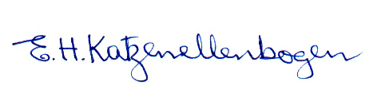

E.H. Katzenellenbogen

29 February 2016