6 November 2015

To whom it may concern

Language editing of article

This is to confirm that I, the undersigned, edited the article titled Towards a matrix for the advancement of black working class students in South Africa's historically privileged universities by Dr MG Steyn and that the Chicago Manual Style author-date system was used by the author.

Yours faithfully

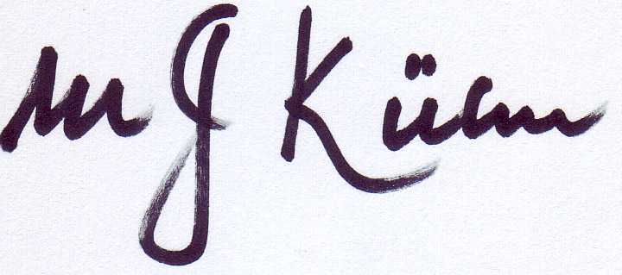

Prof. MJ [Tinus] Kühn

