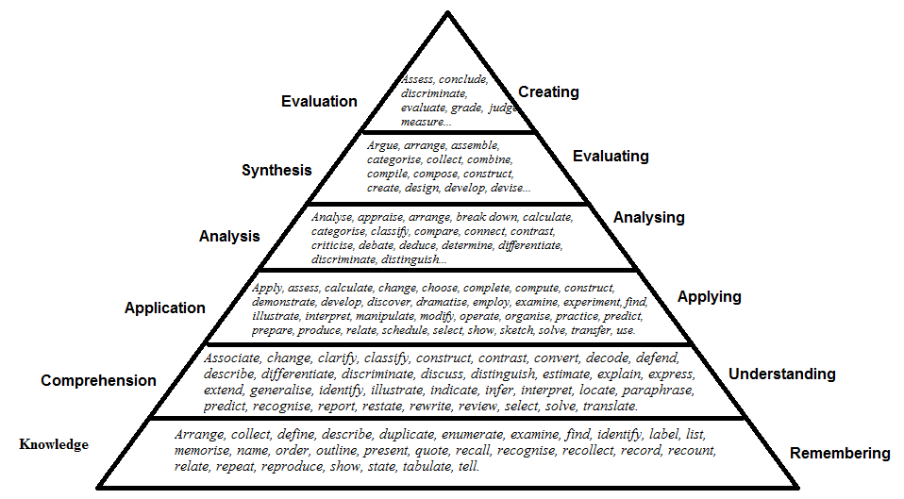
Figure 1: Benjamin Bloom Cognitive levels of outcomes and keywords

