Table 1: Statistical results for Logistic Regression second-year dropout model
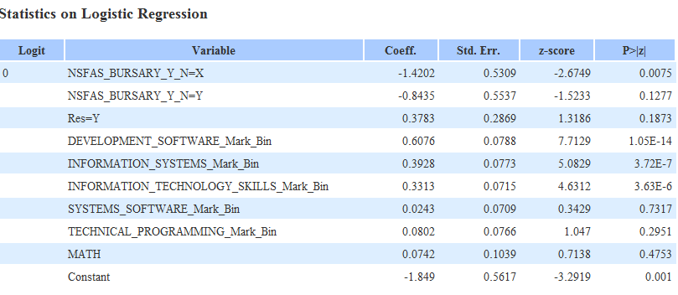

Table 2: Confusion matrix for Logistic Regression dropout model
 | True positives | False positives | True negatives | False negatives | Sensitivity | Specificity | F-measure | Accuracy | Cohen’s Kappa
Dropout = 0 | 299 | 28 | 77 | 20 | 0.937 | 0.733 | 0.926
Dropout = 1 | 77 | 20 | 299 | 28 | 0.733 | 0.937 | 0.762
Overall |  |  |  |  |  |  |  | 0.887 | 0.688

Table 3: Comparison of the accuracy of the Logistic Regression, Naïve Bayes, and Decision Tree models
Statistic | Logistic Regression | Decision Tree | Naïve Bayes
AUC* | 0.9159 | 0.8457 | 0.9194
PCC† (%) | 88.6 | 87.5 | 87.7
Error (%) | 11.3 | 12.5 | 12.3
*Area under the receiver operating characteristic curve.
†Percentage correctly classified.

