Figures

Original sentences on the board | Rewritten by student XXX
The food in the cafeteria is tasty (Smith, 2014).  Cafeteria food is unhealthy since it is often deep fried (Brown, 2015).  It is time-saving and convenient for students to buy food in the cafeteria rather than to make their own (Jones, 2012). | Students prefer to buy food in the university cafeteria since it saves time, and is convenient and tasty. Unfortunately it is unhealthy since most of the food is prepared in oil.
Figure 1: First draft of paraphrasing activity

Referenced version | Rewritten by student XXX
Students prefer to buy food in the university cafeteria since it saves time, and is convenient (Jones, 2012) and tasty (Smith, 2014). Unfortunately it is unhealthy since most of the food is prepared in oil (Brown, 2015). | Assignment by student XXX  Students prefer to buy food in the university cafeteria since it saves time, and is convenient (Jones, 2014) and tasty (Smith, 2014). Unfortunately it is unhealthy since most of the food is prepared in oil (Brown, 2015). This implies that…
Figure 2: Second draft of paraphrasing exercise
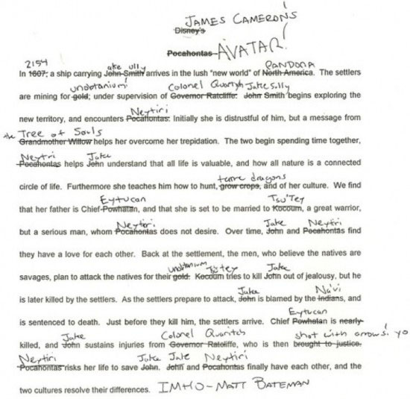
Figure 3: Avatar is Pocahontas in Space

