Figure 1: Programme components

Page 8/9 under Overall action research context: – saved has jpeg file.

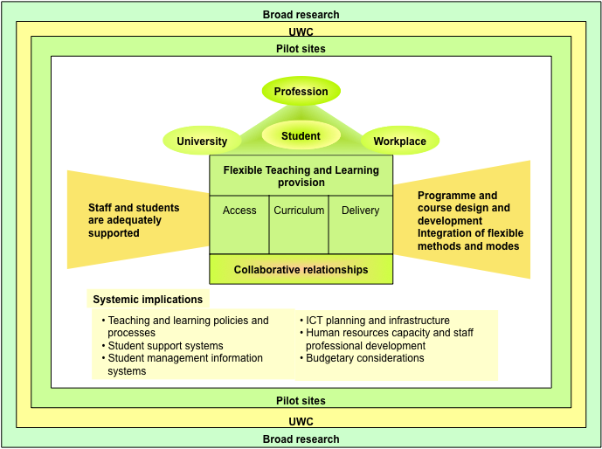
Programme Components 1 (DLL Strategic Plan, 2012)

