Figure 1: The relationship between Geography module results and incoming PTEEP scores



Figure 2: Geography performance based on EFL versus ESL



Figure 3: Performance based on Gender

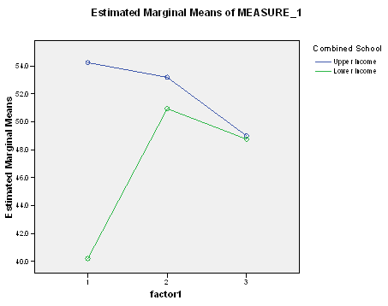

Figure 4: Performance based on school

Figure 5: Graduation rate, persistence in the system

Figure 6: Distinctions and PTEEP score

Figure 7: Relationship between PTEEP score and supplementary examinations written

Figure 8: Links between persistence, supplementary examinations

Figure 9: Supplementary examinations compared to distinctions obtained.

Figure 10: Comparing January PTEEP scores to number of modules failed.

Figure 11: Failure, persistence and graduation rates