Jackie Viljoen
Language Editor and Translator
16 Bergzicht Gardens
Fijnbos Close
STRAND 7140
Tax number 1394/085/02/9

Accredited member of the South African Translators’ Institute No. 1000017
Member of the Professional Editors’ Group (PEG)
Associate member of SAFREA No. SAF03316

 +27 21 854 5095  082 783 0263  086 585 3740
Postal address: 16 Bergzicht Gardens, Fijnbos Close, STRAND 7140 South Africa
Invoice
To: Judith Terblanche Date: 31 January 2019

Invoice number: Terblanche.01/2020

Type of work: Editing of four articles and reference lists
Time worked at R450 per hour:

TIME SCHEDULE

TEXT | PAGES | TIME
1 Decoloniality | 15 | 137
2 Foucault | 16 | 246
3 Overall | 15 | 172
4 Research | 15 | 104
References
1 Decoloniality |  | 40 min
2 Foucault |  | 30 min
3 Overall |  | 25 min
4 Research |  | 25 min
TOTAL |  | 754‬  12.6 hours  5 670‬

TARIFF: R450 per hour
TOTAL PAYABLE = R5 670.00

Banking details: ABSA Somerset West 632005
Cheque account 406 509 01 91
Account holder J Viljoen
SWIFT CODE for South Africa ABSAZAJJ
Please use your name as reference
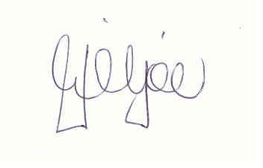
JACKIE VILJOEN

