28/05/2018

To whom it may concern

I confirm that the manuscript titled “Assessing the value of action research: using a World Café to explore the professional journey of nurse educators” by Angeline van Wyngaarden, Ronéll Leech, Isabel Coetzee has been edited by the English Language Science Editor at the Health Sciences Faculty, University of Pretoria. A copy of the edited manuscript is directly available from me.

Sincerely,
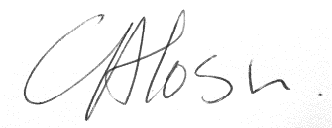

Dr Cheryl Tosh
Room 4-21.4, Level 4, Health Sciences Building
University of Pretoria, Private Bag X323
Arcadia, 0007 South Africa
Tel +27 (0)12 319 2382
Email cheryl.tosh@up.ac.za
www.up.ac.za

Email: cheryl.tosh@up.ac.za

