30 April, 2018

This is to certify that I, Dr P Kaburise, have proofread the manuscript entitled - STUDENTS’ PERCEPTIONS OF SOME FACTORS INFLUENCING ACADEMIC ACHIEVEMENT AT A RURAL SOUTH AFRICAN UNIVERSITY- by T.D Sikhwari, F. Ravhuhali, N. P Lavhelani and F. H Pataka. I have indicated some amendments which the authors have undertaken to effect, before the final manuscript is submitted.

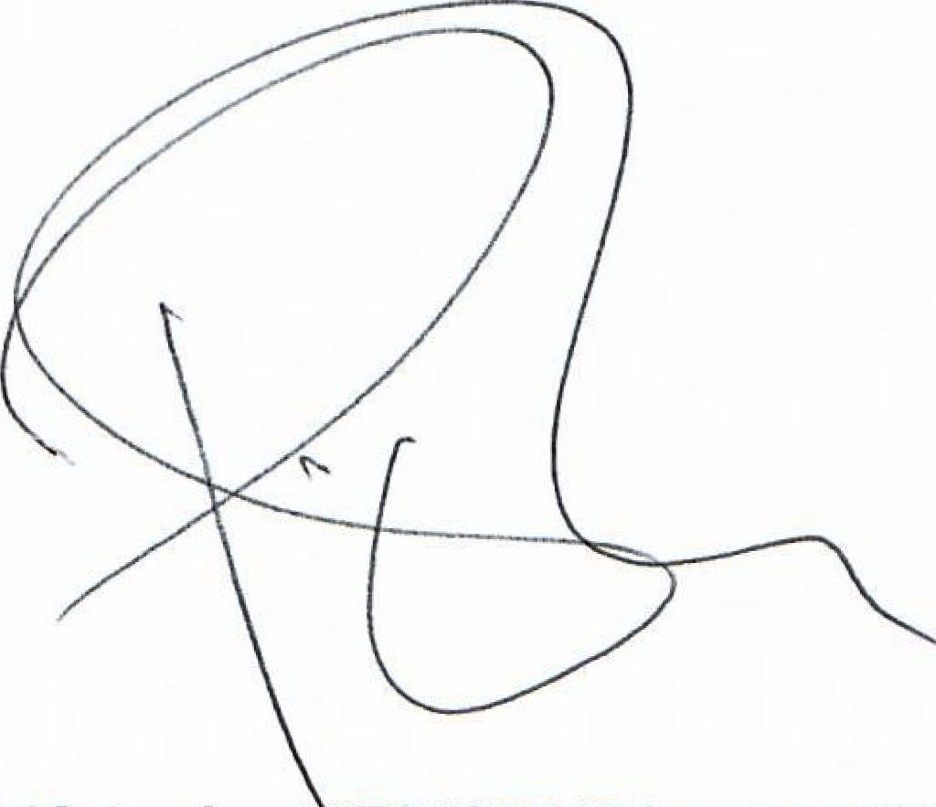
Dr P Kaburise 794927451 / 0711138079)
Dr P Kaburise: BA (Hons) University of Ghana (Legon, Ghana); MEd University of East Anglia (Cambridge/East Anglia, United Kingdom); Cert. Second Language Teaching, (Wellington, New Zealand); PhD University of Pretoria (South Africa)

