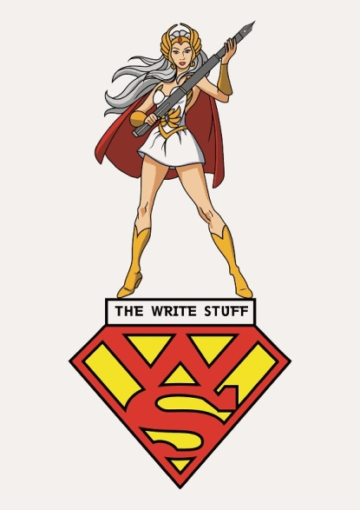
THE WRITE STUFF
Copy-editing &
Proofreading Services

To whom it may concern 12 October 2017

Please note that I have fulfilled the copy-editing and proof-reading obligations required of me by Professor Alethea de Villiers, for the preparation and presentation of her SAJHE article, entitled:
Music graduates and communities of practice

Regards,
Tanya Wyatt

Published author
Qualified editor
The Write Stuff
www.thewritestuff.co.za
tanya@thewritestuff.co.za
083-6844610

