Prof A Minnaar
AJH van der Walt Building 6-85
Department of Curriculum and Instructional Studies,
College of Education, University of South Africa,
Tel:+27 12 429 6887
E-mail: minnaa@unisa.ac.za
4 May 2017
Dear Editor,
We used iThenticate computer programme to check the similarity index for the article. It stands at 67% because it picked up the Master’s dissertation in the Unisa Institutional repository by Prof Gumbo which I supervised. Included is a certificate of proof of the similarity index. The article is based on the dissertation research.

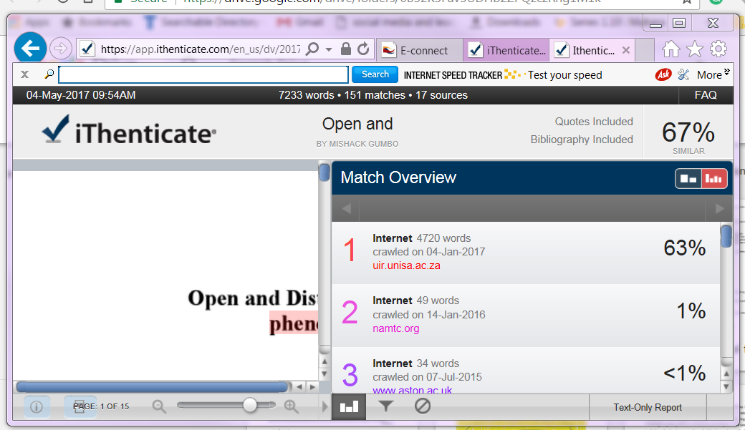

Sincerely,
Professors Gumbo and Minnaar
___________________ 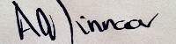
Prof M Gumbo Prof A Minnaar

