Julie Streicher INVOICE
English Language Practitioner No 1016
29 July 2016

Address: 47 Wingerd Drive, Vredekloof 7560, Cape Town, South Africa
Telephone: +27 (0)21 982 2933 +27 83 303 5484
E-mail: julie.streicher@gmail.com

TO:
Stephan Kruger
Accountancy Department
University of Stellenbosch
Stellenbosch
sjkruger@sun.ac.za

No | Date | Job description | Units | Rate | R
1 | 29/7/16 | Language editing of academic paper: Students’ and lecturers’ perceptions of the effect of open-book examinations on teaching practices in accountancy departments | 10525 words | 32c per word | 3368.00
 |  | TOTAL |  |  | R 3368.00

Thank you  Kind regards  Julie Streicher  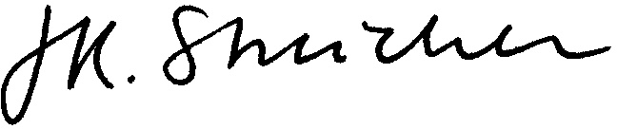 | Bank details for electronic payment:  Julie Streicher  Standard Bank, Stellenbosch  Current account number 073 012815  Branch number 05-06-10-45

