Figure 1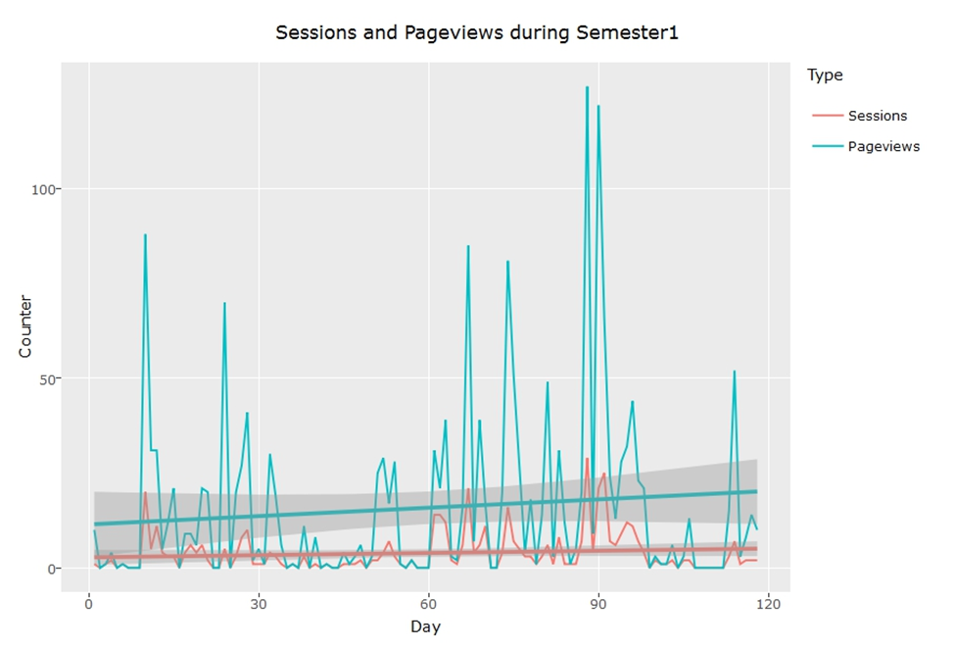Figure 2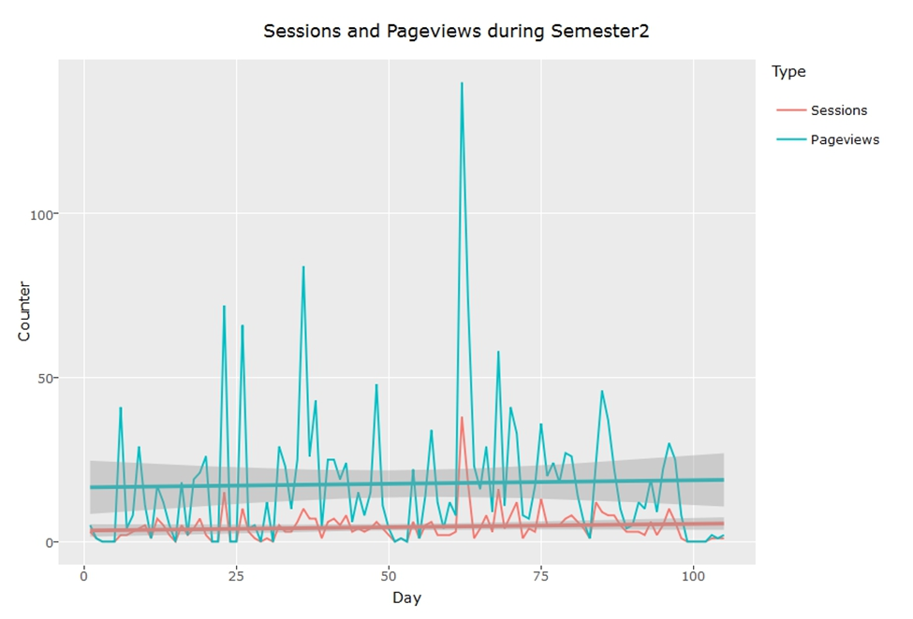
Table1
Module | Blended | F2F | Online | Total
DSC1520 | 24 | 15 | 6 | 45
MAT1503 | 2 | 5 | 6 | 13
MAT1512 | 4 | 5 | 6 | 15
MAT1581 | 3 | 2 | 11 | 16
QMI1500 | 27 | 43 | 11 | 81
Total | 60 | 70 | 40 | 170

Table 2
Module | Blended | F2F | Online | Total
DSC1520 | 2 | 10 | 8 | 20
MAT1503 | 8 | 7 | 21 | 36
MAT1512 | 12 | 8 | 17 | 37
MAT1581 | 8 | 7 | 11 | 26
QMI1500 | 28 | 49 | 11 | 88
STA1510 | 2 | 8 | 3 | 13
Total | 60 | 89 | 71 | 220

Table 3
Module | Blended | F2F | Online | Total
DSC1520 | 23 | 14 | 7 | 44
MAT1503 | 2 | 8 | 10 | 20
MAT1512 | 4 | 5 | 8 | 17
MAT1581 | 4 | 3 | 12 | 19
QMI1500 | 25 | 38 | 12 | 75
Total | 58 | 68 | 49 | 175

Table 4
Module | Blended | F2F | Online | Total
DSC1520 | 3 | 11 | 11 | 25
MAT1503 | 9 | 9 | 25 | 43
MAT1512 | 15 | 8 | 17 | 40
MAT1581 | 11 | 8 | 13 | 32
QMI1500 | 30 | 50 | 14 | 94
STA1510 | 2 | 8 | 4 | 14
Total | 70 | 94 | 84 | 248

Table 5
Module |  | Sem 1 |  |  |  | Sem 2
 |  | Blended | F2F | Online |  | Blended | F2F | Online
DSC1520 | Exam | 0.22500 | 0.87490 | 0.45900 |  | 0.17440 | 0.14080 | 0.83340
 | Asg 1 | 0.00747 | 0.03765 | 0.09376 |  | 0.19740 | 0.00025 | 0.25280
 | Asg 2 | 0.04693 | 0.06643 | 0.72860 |  | 0.49490 | 0.37540 | 0.49950
 | Asg 3 | 0.00002 | 0.00002 | 0.19630 |  | 0.40450 | 0.00044 | 0.00325
MAT1503 | Exam | 0.17080 | 0.54580 | 0.45010 |  | 0.08585 | 0.35670 | 0.00427
 | Asg 1 | 0.40200 | 0.09099 | 0.00918 |  | 0.00004 | 0.00810 | 0.00048
 | Asg 2 | 0.42110 | 0.25470 | 0.00105 |  | 0.51940 | 0.16230 | 0.06347
 | Asg 3 | 0.38410 | 0.25130 | 0.06286 |  | 0.01775 | 0.06701 | 0.03029
MAT1512 | Exam | 0.27010 | 0.86370 | 0.17070 |  | 0.11420 | 0.68820 | 0.01172
 | Asg 1 | 0.83300 | 0.68710 | 0.04972 |  | 0.00340 | 0.04074 | 0.07167
 | Asg 2 | 0.81160 | 0.35700 | 0.43030 |  | 0.06343 | 0.15200 | 0.18930
MAT1581 | Exam | 0.06448 | 0.03134 | 0.94320 |  | 0.51700 | 0.02407 | 0.27620
 | Asg 1 | 0.29970 | 0.06716 | 0.68510 |  | 0.03282 | 0.88310 | 0.06007
 | Asg 2 | 0.17030 | 0.59530 | 0.08238 |  | 0.74160 | 0.06432 | 0.18430
 | Asg 3 | 0.07952 | 0.19660 | 0.72820 |  | 0.14340 | 0.03504 | 0.01676
QMI1500 | Exam | 0.28600 | 0.69780 | 0.87710 |  | 0.00213 | 0.72220 | 0.44910
 | Asg 1 | 0.00001 | 0.00040 | 0.89230 |  | 0.00000 | 0.00593 | 0.51530
 | Asg 2 | 0.00004 | 0.01062 | 0.55440 |  | 0.00001 | 0.00149 | 0.76080
 | Asg 3 | 0.00943 | 0.04150 | 0.54400 |  | 0.00028 | 0.09111 | 0.18630
STA1510 | Exam | No Data | No Data | No Data |  | 0.26780 | 0.92190 | 0.96670
 | Asg 1 | No Data | No Data | No Data |  | 0.11930 | 0.35760 | 0.71250
 | Asg 2 | No Data | No Data | No Data |  | 0.03553 | 0.26160 | 0.82730

Table 6
Module
Semester 1 | Blended |  | F2F |  | Online | All
 | Avg | P-Value | Avg | P-Value | Avg | Avg
DSC1520 | 51.67 | 0.5823 | 42.22 | 0.2662 | 48.89 | 48.66
MAT1503 | 57.00 | 0.6786 | 40.60 | 0.3961 | 43.17 | 42.85
MAT1512 | 36.75 | 0.2250 | 23.00 | 0.1645 | 47.67 | 34.65
MAT1581 | 60.42 | 0.9693 | 61.88 | 0.9885 | 26.48 | 36.48
QMI1500 | 47.70 | 0.9431 | 44.21 | 0.7809 | 38.87 | 45.33
Semester 2 | Blended |  | F2F |  | Online | All
 | Avg | P-Value | Avg | P-Value | Avg | Avg
DSC1520 | 55.00 | 0.9425 | 53.33 | 0.9404 | 39.16 | 46.04
MAT1503 | 37.62 | 0.4131 | 31.71 | 0.2450 | 39.10 | 27.90
MAT1512 | 50.75 | 0.2256 | 36.25 | 0.0455 | 57.35 | 41.88
MAT1581 | 36.09 | 0.2813 | 54.11 | 0.7931 | 41.70 | 37.22
QMI1500 | 48.69 | 0.9394 | 38.03 | 0.3401 | 40.30 | 39.94
STA1510 | 50.00 | 0.9809 | 32.00 | 0.8747 | 25.33 | 41.05

Figure 3
