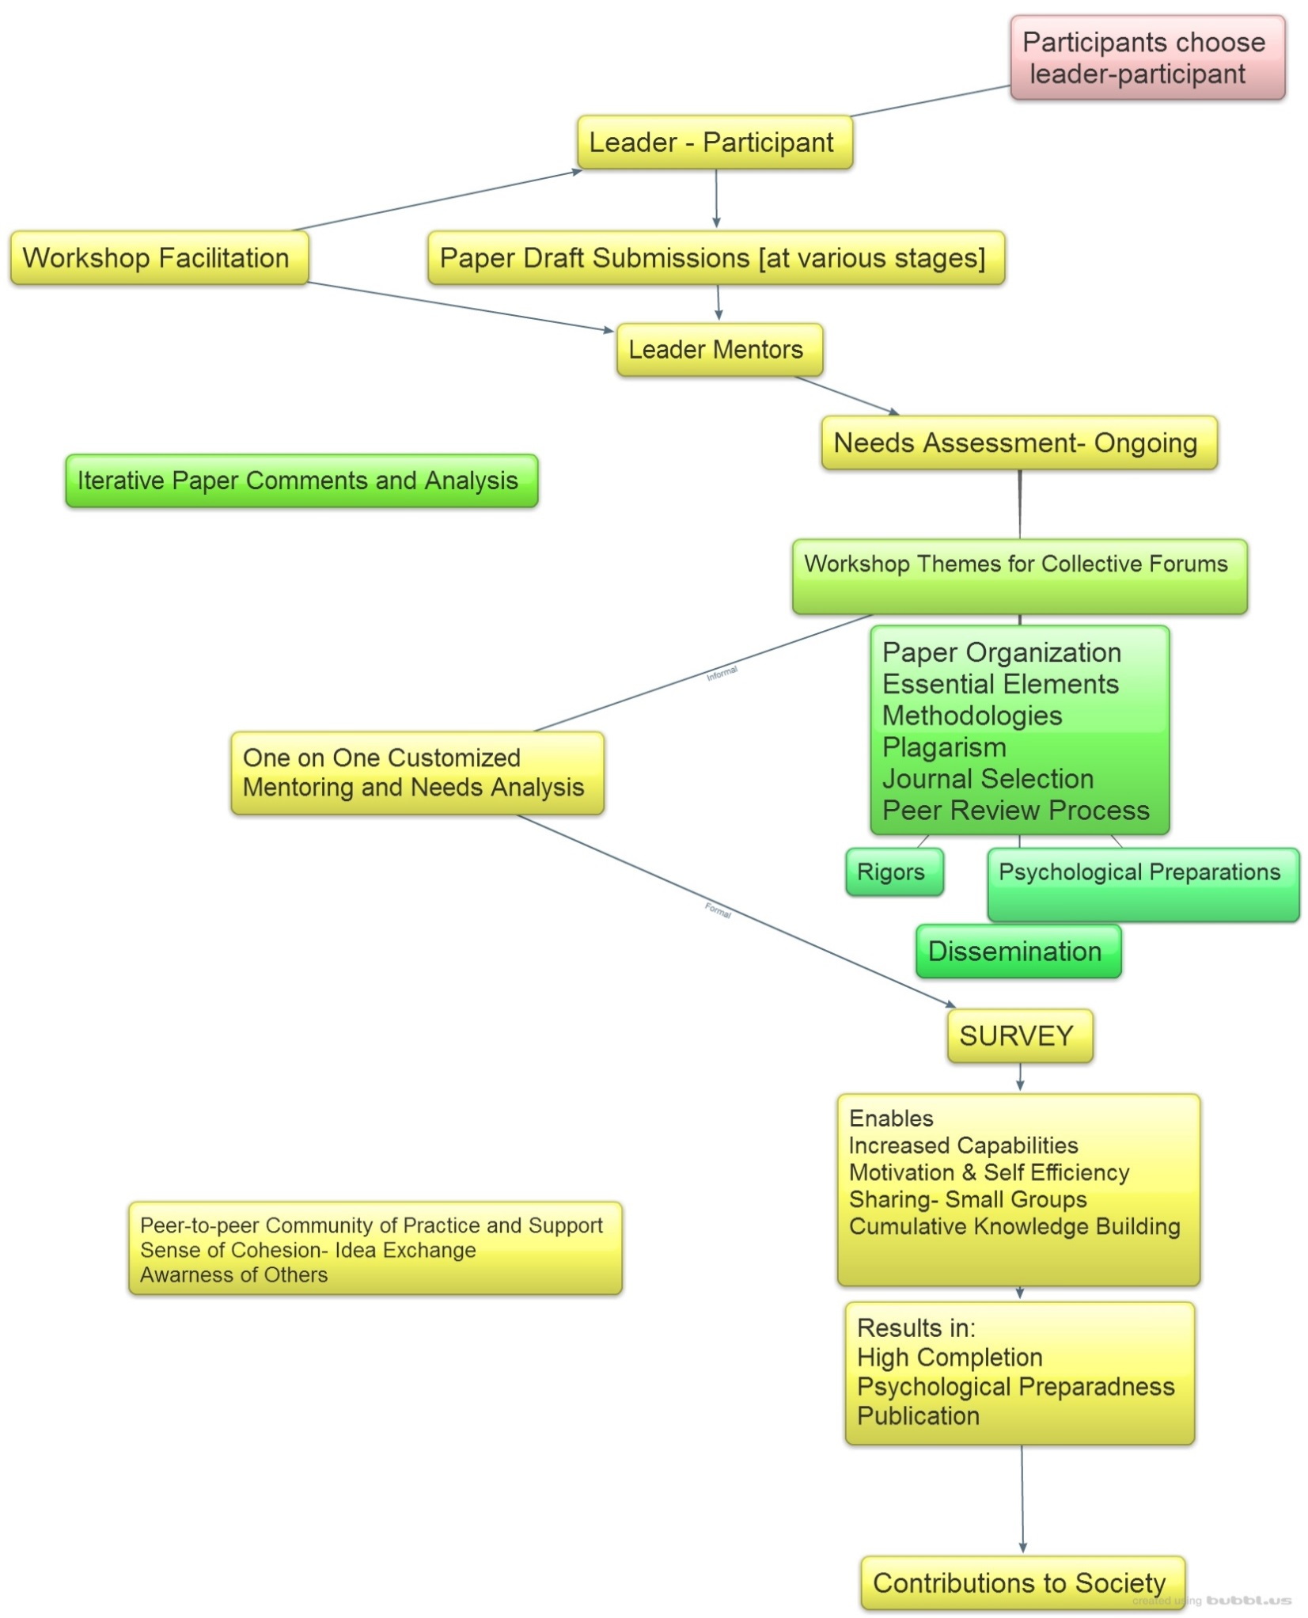.

**Figure 1:** **Innovation in designing and conducting writing retreats for academic staff in higher education**

**[The figure illustrates the features of the June 2016 writing retreat discussed in this article].**

**Format used to generate Figure: Windows Photo Viewer**

**Innovation in designing and conducting writing retreats for academic staff in higher education”**

**University or College Community of Practice**