Supplementary Table 1. List of taste and mouth-feel attributes and their corresponding standards for the sensory evaluation of 2014 and 2015 wines.
Taste and mouth-feel
Sweetness | Different concentrations of sucrose  (Sigma-Aldrich)
Acidity | Different concentrations of tartaric acid  (Sigma-Aldrich)
Bitterness | Different concentrations of caffeine (caffeine tablet)
Astringency | Alum Crystals B.P.  (Alpha Pharm)  (0, 0.25, 0.5, 1 g/L)
Body | Carboxymethyl cellulose (CMC) solution (0.5/1/2 g/L)
Alcohol burn | 96% Ethanol  (13%, 15%)

Supplementary Table 2. Multivariate test of significance (Wilks test) for the impact of the different variables in the individual phenolic composition of all 2014 wines over time.
 | F | p
Training system | 13.183 | 0.000
Vigour | 5.962 | 0.000
Ripeness | 53.010 | 0.000
Time | 28.321 | 0.000
Training system*Vigour | 3.748 | 0.001
Training system*Ripeness | 13.053 | 0.000
Vigour*Ripeness | 2.204 | 0.031
Training system*Time | 4.114 | 0.000
Vigour*Time | 2.491 | 0.000
Ripeness*Time | 4.732 | 0.000
Training system*Vigour*Ripeness | 5.032 | 0.000
Training system*Vigour*Time | 1.242 | 0.169
Training system*Ripeness*Time | 2.455 | 0.000
Vigour*Ripeness*Time | 1.263 | 0.151
Training system*Vigour*Ripeness*Time | 2.175 | 0.000

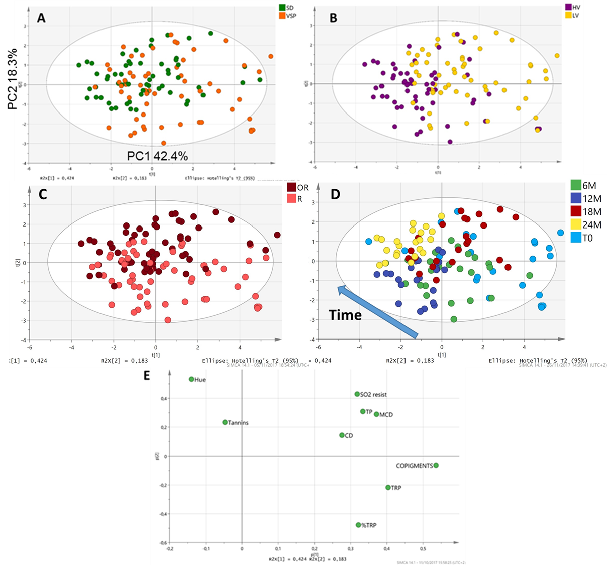
Supplementary Figure 1. Sample distribution of 2014 wines according to their phenolic content analysed by spectrophotometric methods. A) PCA scores scatter plot coloured according to the training system. B) PCA scores scatter coloured according to the vine vigour. C) PCA scores scatter plot coloured according to grape ripening. D) PCA scores scatter plot coloured according to the sampling stages. E) Loading plot with the colour and phenolic parameters: CD (colour density), MCD (modified colour density), TP (total phenolics), TRP (total red pigments), SO2 resist (SO2 resistant pigments).

Supplementary Table 3. Intensity values (0-100) for the taste and mouth-feel attributes of 2014 wines evaluated after 6 months of storage. The different letters indicate significant differences (ANOVA, p < 0.05) between the treatments.

Wine 6M | SD HV R | SD LV R | SD HV OR | SD LV OR | VSP HV R | VSP LV R | VSP HV OR | VSP LV OR
Acidity | 55.33 ± 14.64 ^{ab} | 56.55 ± 14.11 ª | 50.79 ± 15.10 ^{bc} | 48.29 ± 14.01 ^{b} | 53.77 ± 14.17 ^{ab} | 50.65 ± 15.82 ^{bc} | 47.14 ± 14.55 ^{c} | 46.59 ± 14.20 ^{c}
Sweetness | 28.27 ± 11.64 ^{bc} | 25.83 ± 11.44 ^{c} | 31.42 ± 14.03 ^{ab} | 33.61 ± 14.27 ª | 29.17 ± 13.32 ^{bc} | 29.62 ± 13.87 ^{b} | 30.20 ± 13.23 ^{ab} | 28.79 ± 13.25 ^{bc}
Body | 38.02 ± 10.96 ^{c} | 37.38 ± 11.80 ^{c} | 42.91 ± 11.62 ª | 43.70 ± 11.31 ª | 39.41 ± 11.98 ^{bc} | 42.06 ± 11.91 ^{ab} | 43.58 ± 12.62 ª | 43.20 ± 11.15 ª
Alcohol burn | 44.95 ± 14.86 ^{b} | 45.64 ± 15.66 ^{b} | 47.82 ± 14.94 ^{ab} | 50.80 ± 14.25 ª | 46.33 ± 13.96 ^{ab} | 45.98 ± 16.55 ^{b} | 50.59 ± 12.90 ª | 48.20 ± 15.37 ^{ab}
Astringency | 42.77 ± 15.96 ^{c} | 46.47 ± 14.90 ^{abc} | 45.88 ± 14.64 ^{bc} | 44.17 ± 15.39 ^{bc} | 43.92 ± 15.73 ^{bc} | 45.32 ± 15.61 ^{bc} | 50.47 ± 15.41 ª | 47.35 ± 14.84 ^{ab}
Bitterness | 44.06 ± 17.32 ^{c} | 43.26 ± 16.21 ^{c} | 49.38 ± 15.84 ^{b} | 51.95 ± 19.49 ^{ab} | 43.88 ± 16.73 ^{c} | 50.23 ± 16.96 ^{ab} | 54.82 ± 15.59 ª | 54.17 ± 16.58 ^{ab}

Supplementary Table 4. Intensity values (0-100) for the taste and mouth-feel attributes of 2014 wines evaluated after 12 months of storage. The different letters indicate significant differences (ANOVA, p < 0.05) between the treatments.
Wine 12M | SD HV R | SD LV R | SD HV OR | SD LV OR | VSP HV R | VSP LV R | VSP HV OR | VSP LV OR
Acidity | 47.79 ± 1.62^{c} | 52.93 ± 1.32 ^{ab} | 47.83 ± 1.32 ^{c} | 49.31 ± 1.47 ^{bc} | 55.68 ± 1.35 ª | 49.71 ± 1.53 ^{bc} | 46.55 ± 1.44 ^{c} | 51.95 ± 1.19 ^{ab}
Sweetness | 45.99 ± 1.61 ^{b} | 39.54 ± 1.40 ^{c} | 51.13 ± 1.67 ª | 47.65 ± 1.53 ^{ab} | 37.04 ± 1.31 ^{c} | 37.64 ± 1.61 ^{c} | 46.06 ± 1.59 ^{b} | 39.06 ± 1.53 ^{c}
Body | 47.50 ± 1.55 ^{bc} | 44.41 ± 1.63 ^{cde} | 56.84 ± 1.43 ª | 56.14 ± 1.33 ª | 40.89 ± 1.66 e | 42.45 ± 1.52 de | 51.73 ± 1.54 ^{b} | 46.20 ± 1.64 ^{cd}
Alcohol burn | 45.29 ± 1.88 ^{cd} | 45.13 ± 1.66 ^{cd} | 51.38 ± 1.34 ^{ab} | 55.54 ± 1.51 ª | 40.10 ± 1.58 e | 41.26 ± 1.58 de | 51.24 ± 1.70 ^{ab} | 48.15 ± 1.72 ^{bc}
Astringency | 45.08 ± 2.02 ^{ab} | 47.84 ± 2.00 ª | 46.48 ± 1.62 ª | 46.88 ± 1.63 ª | 43.64 ± 2.13 ^{ab} | 40.25 ± 1.92 ^{b} | 48.75 ± 2.09 ª | 47.35 ± 1.74 ª
Bitterness | 34.96 ± 1.89 ^{d} | 37.98 ± 1.86 ^{d} | 46.73 ± 1.87 ^{ab} | 51.74 ± 2.38 ª | 35.14 ± 2.04 ^{d} | 39.40 ± 2.05 ^{cd} | 44.76 ± 2.50 ^{bc} | 43.93 ± 1.92 ^{bc}

Supplementary Table 5.Test of significance (Test of SS Whole model vs SS residual) for the colour and phenolics (spectrophotometric results) of 2015 wines at AF.
 | F | p
Colour Density | 8.976 | 0.006
Hue | 3.712 | 0.061
MCD | 8.761 | 0.007
TP | 12.697 | 0.002
TRP | 4.798 | 0.034
% TRP | 5.075 | 0.029
Tannins | 1.924 | 0.204
SO2 Resistant | 123.970 | 0.000
Copigments | 4.207 | 0.046

Supplementary Table 6. Test of significance (Test of SS Whole model vs SS residual) for the individual phenolic compounds of 2015 wines at AF.
 | F | p
Gallic acid | 1.373 | 0.319
Catechin | 1.979 | 0.196
B1 | 0.735 | 0.560
Polymeric phenols | 6.768 | 0.014
Total hydroxycinnamic acids | 29.804 | 0.000
Total flavonols | 6.237 | 0.017
Total glucosylated anthocyanins | 12.925 | 0.002
Total acetylated | 12.183 | 0.002
Total coumaroylated | 29.854 | 0.000
Polymeric pigments | 4.506 | 0.039

Supplementary Table 7. Multivariate test of Significance (Wilks test) for colour and phenolics (measured by spectrophotometric methods) in all 2015 wines made from different grape ripeness levels (21ºBrix. 23ºBrix. 24ºBrix and 25ºBrix) during 18 months of bottle ageing.
 | F | p
Ripeness | 17.710 | 0.000
Time | 30.940 | 0.000
Ripeness*Time | 3.510 | 0.000

Supplementary Table 8. Univariate test of Significance for colour and phenolics (measured by spectrophotometric methods) in all 2015 wines made from different grape ripeness (21ºBrix. 23ºBrix. 24ºBrix and 25ºBrix) during 18 months of bottle ageing.
 | CD  F | CD  p | Hue  F | Hue  p | MCD  F | MCD  p | TP  F | TP  p
Ripeness | 66.522 | 0.000 | 18.89 | 0.000 | 53.909 | 0.000 | 20.682 | 0.000
Time | 39.558 | 0.000 | 69.19 | 0.000 | 38.296 | 0.000 | 11.401 | 0.000
Ripeness*Time | 0.630 | 0.804 | 3.63 | 0.001 | 3.380 | 0.002 | 1.016 | 0.453
 | TRP  F | TRP  p | Tannins  F | Tannins  p | SO₂  resistant  F | SO₂  resistant  p | Copigments  F | Copigments  p
Ripeness | 21.661 | 0.000 | 44.623 | 0.000 | 92.068 | 0.000 | 1.305 | 0.285
Time | 70.650 | 0.000 | 3.434 | 0.016 | 130.053 | 0.000 | 19.528 | 0.000
Ripeness*Time | 1.829 | 0.076 | 3.429 | 0.002 | 11.921 | 0.000 | 4.151 | 0.000

Supplementary Table 9. Multivariate test of Significance (Wilks test) for individual phenolic compounds in all 2015 wines made from different grape ripeness (21ºBrix. 23ºBrix. 24ºBrix and 25ºBrix) during 18 months of bottle ageing.
 | F | p
Ripeness | 29.544 | 0.000
Time | 15.418 | 0.000
Ripeness*Time | 2.592 | 0.000

Supplementary Table 10. Univariate test of significance for the individual and group of phenolic compounds in 2015 wines made from grapes at different ripeness levels (21ºBrix. 23ºBrix. 24ºBrix and 25ºBrix) during 18 months of bottle ageing.
 | Gallic acid  F | Gallic acid  p | Catechin  F | Catechin  p | B1  F | B1  p | Pol. phenols  F | Pol. phenols  p | Hydroxy. Ac.  F | Hydroxy. Ac.  p
Ripeness | 40.640 | 0.000 | 1.071 | 0.374 | 1.345 | 0.275 | 167.903 | 0.000 | 41.740 | 0.000
Time | 112.610 | 0.000 | 2.061 | 0.106 | 1.689 | 0.174 | 1.665 | 0.180 | 51.730 | 0.000
Ripeness * Time | 3.540 | 0.002 | 4.383 | 0.000 | 3.655 | 0.001 | 4.648 | 0.000 | 1.430 | 0.198
 | Flavonols  F | Flavonols  p | Gluc. anth.  F | Gluc. anth.  p | Acyl. anth.  F | Acyl. anth.  p | Coum. anth.  F | Coum. anth.  p | Pol.  pigment  F | Pol.  Pigment  p
Ripeness | 7.693 | 0.000 | 58.245 | 0.000 | 64.849 | 0.000 | 54.959 | 0.000 | 64.590 | 0.000
Time | 66.120 | 0.000 | 106.509 | 0.000 | 148.839 | 0.000 | 151.668 | 0.000 | 0.945 | 0.449
Ripeness * Time | 1.596 | 0.137 | 8.461 | 0.000 | 11.426 | 0.000 | 13.101 | 0.000 | 2.568 | 0.014

Supplementary Table 11. Test of significance (Test of SS Whole model vs SS residual) for the taste and mouth-feel attributes in 2015 wines after 6 months of storage.
 | Acidity |  | Sweetness |  | Body |  | Alcohol burn |  | Astringency |  | Bitterness
 | F | p | F | p | F | p | F | p | F | p | F | p
Ripeness | 2.976 | 0.059 | 3.726 | 0.030 | 20.379 | 0.000 | 47.244 | 0.000 | 14.592 | 0.000 | 29.788 | 0.000
Time | 1.424 | 0.278 | 9.352 | 0.022 | 2.644 | 0.155 | 0.011 | 0.918 | 0.000 | 0.988 | 0.000 | 0.987
Ripeness*Time | 14.400 | 0.000 | 9.919 | 0.000 | 2.212 | 0.122 | 2.599 | 0.084 | 3.664 | 0.032 | 2.671 | 0.078

Supplementary Table 12. Wine alcohol % for the wines after 12M.
21⁰Brix | 23⁰Brix | 24⁰Brix | 25⁰Brix
11.82 ± 0.39 ^{d} | 12.72 ± 0.09 ^{c} | 14.12 ± 0.04 ^{b} | 15.83 ± 0.05 ª

