Figures
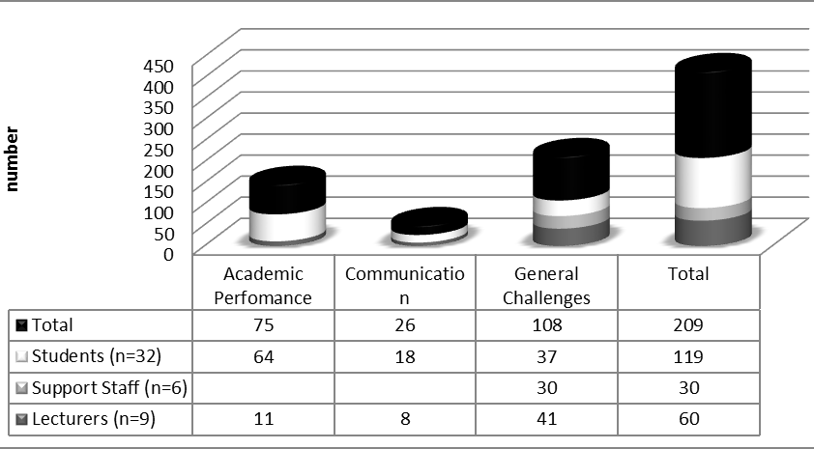
Figure 1. Universal language challenges experienced by international students attending the Bellville and Cape Town CPUT campuses

Figure 2. Universal language barriers experienced by international students attending the Bellville and Cape Town CPUT campuses

Figure 3. Universal language support, to be implemented to international students attending the Bellville and Cape Town CPUT campuses

Figure 4. Socio-Cultural adaptation experienced by international students attending the Bellville and Cape Town CPUT campuses

